* **Masters / Screens**
  + **Company :-**
* A company is a legal entity made up of an association of people carrying on a commercial or industrial enterprise.
* A parent company is a larger organization which consists of one or more child companies. A child company is a subsidiary of a parent company.
* You can set up multiple companies, the company structure can be parallel, i.e., sister companies, parent-child companies, or a combination of both.
* Company Screen shall have the following fields :

| Label (Fields) | Type (Fields) | Mandatory (Fields) | Options (Fields) |
| --- | --- | --- | --- |
| Company | Data | 1 |  |
| Abbr | Data | 1 |  |
| Is Group | Check | 0 |  |
| Domain | Link | 0 | Domain |
| Parent Company | Link | 0 | Company |
| Default Currency | Link | 1 | Currency |
| Default Letter Head | Link | 0 | Letter Head |
| Default Holiday List | Link | 0 | Holiday List |
| Default Finance Book | Link | 0 | Finance Book |
| Default Selling Terms | Link | 0 | Terms and Conditions |
| Default Buying Terms | Link | 0 | Terms and Conditions |
| Default Warehouse for Sales Return | Link | 0 | Warehouse |
| Default In-Transit Warehouse | Link | 0 | Warehouse |
| Country | Link | 1 | Country |
| Create Chart Of Accounts Based On | Select | 0 | Standard Template  Existing Company |
| Chart Of Accounts Template | Select | 0 |  |
| Existing Company | Link | 0 | Company |
| Tax ID | Data | 0 |  |
| Date of Establishment | Date | 0 |  |
| Monthly Sales Target | Currency | 0 | default_currency |
| Sales Monthly History | Small Text | 0 |  |
| Transactions Annual History | Code | 0 |  |
| Total Monthly Sales | Currency | 0 | default_currency |
| Default Bank Account | Link | 0 | Account |
| Default Cash Account | Link | 0 | Account |
| Default Receivable Account | Link | 0 | Account |
| Round Off Account | Link | 0 | Account |
| Round Off Cost Center | Link | 0 | Cost Center |
| Write Off Account | Link | 0 | Account |
| Exchange Gain / Loss Account | Link | 0 | Account |
| Unrealized Exchange Gain/Loss Account | Link | 0 | Account |
| Unrealized Profit / Loss Account | Link | 0 | Account |
| Allow Account Creation Against Child Company | Check | 0 |  |
| Default Payable Account | Link | 0 | Account |
| Default Employee Advance Account | Link | 0 | Account |
| Default Cost of Goods Sold Account | Link | 0 | Account |
| Default Income Account | Link | 0 | Account |
| Default Deferred Revenue Account | Link | 0 | Account |
| Default Deferred Expense Account | Link | 0 | Account |
| Default Payroll Payable Account | Link | 0 | Account |
| Default Expense Claim Payable Account | Link | 0 | Account |
| Default Payment Discount Account | Link | 0 | Account |
| Default Cost Center | Link | 0 | Cost Center |
| Credit Limit | Currency | 0 | default_currency |
| Default Payment Terms Template | Link | 0 | Payment Terms Template |
| Enable Perpetual Inventory | Check | 0 |  |
| Enable Provisional Accounting For Non Stock Items | Check | 0 |  |
| Default Inventory Account | Link | 0 | Account |
| Stock Adjustment Account | Link | 0 | Account |
| Stock Received But Not Billed | Link | 0 | Account |
| Default Provisional Account | Link | 0 | Account |
| Expenses Included In Valuation | Link | 0 | Account |
| Accumulated Depreciation Account | Link | 0 | Account |
| Depreciation Expense Account | Link | 0 | Account |
| Series for Asset Depreciation Entry (Journal Entry) | Data | 0 |  |
| Expenses Included In Asset Valuation | Link | 0 | Account |
| Gain/Loss Account on Asset Disposal | Link | 0 | Account |
| Asset Depreciation Cost Center | Link | 0 | Cost Center |
| Capital Work In Progress Account | Link | 0 | Account |
| Repair and Maintenance Account | Link | 0 | Account |
| Asset Received But Not Billed | Link | 0 | Account |
| Exception Budget Approver Role | Link | 0 | Role |
| Company Logo | Attach Image | 0 |  |
| Date of Incorporation | Date | 0 |  |
|  | HTML | 0 |  |
| Date of Commencement | Date | 0 |  |
| Phone No | Data | 0 | Phone |
| Fax | Data | 0 | Phone |
| Email | Data | 0 | Email |
| Website | Data | 0 |  |
| Company Description | Text Editor | 0 |  |
| Registration Details | Code | 0 |  |
| Lft | Int | 0 |  |
| Rgt | Int | 0 |  |
| old_parent | Data | 0 |  |

* + **Charts of Accounts :**
    - The Chart of Accounts helps you to answer questions like:
* What is your organization worth?
* How much debt have you taken?
* How much profit are you making (and hence paying tax)?
* How much are you selling?
* What is your expense break-up?
  + - As someone managing a business, it is very valuable to see how well your business is doing.
    - In the Chart of Accounts list, you can open group accounts which contain other accounts.
      * There are options to “Add Child” in an account, Edit or Delete the account.
      * The option to create a child account will only appear if you click on a Group (folder) type Account.
      * Enter a name for the account.
      * Enter a number for the account.
      * Tick 'Is Group' if you want this to be a group account which can contain other accounts.
      * Select the Account Type. Selecting this is important as some fields allow selecting only specific types of accounts.
      * Change the currency if this account will be used for transactions with different currencies. By default, it's the Company's currency.
      * The fields are explained as follows:
        + Company
        + Parent Account
        + Frozen (If the account is frozen, entries are allowed to restricted users.)
        + Balance must be

Debit

Credit

* + - * + Root Type
        + Report Type
  + **Accounts Settings :** 
    - There are various account settings in to restrict and configure actions in the Accounting module

### **1. Over Billing Allowance (%)**

* + - * The percentage by which you can overbill transactions. For example, if the order value is $100 for an Item and the percentage here is set as 10% then you are allowed to bill for $110.

### **2. Role Allowed to Over Bill**

### Users with this role are allowed to over bill above the allowance percentage.

### **3. Role allowed to bypass Credit Limit**

### Select the role that is allowed to submit transactions that exceed credit limits set. The credit limit can be set in the Customer form.

### **4. Check Supplier Invoice Number Uniqueness**

* + - * When checked, Purchase Invoices with the same 'Supplier Invoice No' will not be allowed. This is useful to avoid duplicate entries.

### **5. Unlink Payment on Cancellation of Invoice**

* + - * If checked, the system will unlink the payment against the respective invoice. By default, if a Payment Entry is submitted, the linked invoice cannot be canceled until the Payment Entry is also canceled. On unlinking, you can now cancel and amend the invoices. But the payments are not linked and considered as advance payments.

### **6. Automatically Fetch Payment Terms from Order**

### Enabling this will automatically fetch the Payment Terms from a Purchase/Sales Order to its linked Purchase/Sales Invoice.

### **7. Delete Accounting and Stock Ledger Entries on deletion of Transaction**

### Enabling this will allow the deletion of linked General Ledger and Stock Ledger Entries on deleting invoices and receipts. This can be checked if you don't want to lose the document ID after canceling the document. You can now cancel and delete the document to get the same document ID again.

### **8. Book Asset Depreciation Entry Automatically**

* + - * When checked, an automatic entry for an asset depreciation will be created based on the first date set. For example, yearly depreciation for an item will be scheduled for the next 3/4 years based on the Number of Depreciations Booked set in the Asset master.

**9. Unlink Advance Payment on Cancellation of Order**

* + - * Similar to the previous option, this unlinks any advance payments made against Purchase/Sales Orders.

### **10. Enable Common Party Accounting**

### If checked, an adjustment Journal Entry will be posted automatically on creation of Sales/Purchase Invoices against common Customer & Supplier.

### **11. Create Ledger Entries for Change Amount**

### If checked, for a Point of Sale invoice, the system will post ledger entries considering the change amount given.

### **12. Enable Discount Accounting**

* + - * If checked, Discount Accounts can be added in the Items table of Sales Invoices, which will allow you to account for Discounts applied on Items more efficiently. It also lets you add Default Discount Accounts for Items, which will be fetched automatically when the Item is added to a Sales Invoice.
    - Account Setting shall have the following fields:-

| Label (Fields) | Type (Fields) | Mandatory (Fields) | Options (Fields) |
| --- | --- | --- | --- |
| Over Billing Allowance (%) | Currency | 0 |  |
| Role Allowed to Over Bill | Link | 0 | Role |
| Make Payment via Journal Entry | Check | 0 |  |
| Check Supplier Invoice Number Uniqueness | Check | 0 |  |
| Unlink Payment on Cancellation of Invoice | Check | 0 |  |
| Automatically Fetch Payment Terms from Order | Check | 0 |  |
| Delete Accounting and Stock Ledger Entries on deletion of Transaction | Check | 0 |  |
| Book Asset Depreciation Entry Automatically | Check | 0 |  |
| Unlink Advance Payment on Cancellation of Order | Check | 0 |  |
| Enable Common Party Accounting | Check | 0 |  |
| Create Ledger Entries for Change Amount | Check | 0 |  |
| Enable Discount Accounting | Check | 0 |  |
| Determine Address Tax Category From | Select | 0 | Billing Address  Shipping Address |
| Automatically Add Taxes and Charges from Item Tax Template | Check | 0 |  |
| Accounts Frozen Till Date | Date | 0 |  |
| Role Allowed to Set Frozen Accounts and Edit Frozen Entries | Link | 0 | Role |
| Credit Controller | Link | 0 | Role |
| Book Deferred Entries Based On | Select | 0 | Days  Months |
| Automatically Process Deferred Accounting Entry | Check | 0 |  |
| Book Deferred Entries Via Journal Entry | Check | 0 |  |
| Submit Journal Entries | Check | 0 |  |
| Show Inclusive Tax in Print | Check | 0 |  |
| Show Payment Schedule in Print | Check | 0 |  |
| Allow Stale Exchange Rates | Check | 0 |  |
| Stale Days | Int | 0 |  |
| Use Custom Cash Flow Format | Check | 0 |  |

* + **Fiscal Year :**
    - A Fiscal Year is used to record and report the transactions for the year.
    - If you have multiple companies sharing the same Fiscal Year, you can add it as shown in the following screenshot:

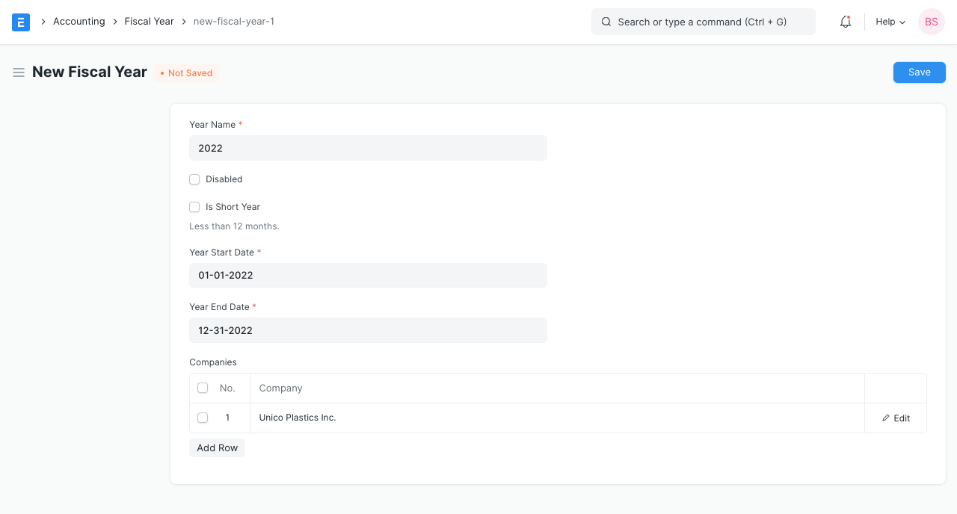

Note -

1.New Fiscal Year should be created each year, at the end of the current fiscal year.

2.Three days prior to the end of the current Fiscal Year, the system checks if a new Fiscal Year for the incoming year is already created. If not, then the system auto-creates a new Fiscal Year.

* + **Accounting Dimensions :**
    - Dimensional accounting means tagging each transaction with appropriate dimensions like Branch, Business Unit, etc. This allows you to maintain each segment separately, thereby limiting the overall maintenance on GL accounts and your Chart of Accounts remains pure.
    - Cost Center and Project are treated as dimensions by default. On setting a field in Accounting Dimension, that field will be added in transactions reports where applicable.
    - The fields are explained as follows:

| Label (Fields) | Type (Fields) | Mandatory (Fields) | Options (Fields) |
| --- | --- | --- | --- |
| Reference Document Type | Link | 1 | DocType |
| Dimension Name | Data | 0 |  |
| Fieldname | Data | 0 |  |
| Dimension Defaults | Table | 0 | Accounting Dimension Detail |
| Disable | Check | 0 |  |

* + **Finance Book :**
    - A Finance Book is a *book* against which all the accounting entries are booked.
    - You can have multiple finance books. For example, one book for tax authorities and another for stockholders. This is useful if you have to report depreciation and other values in different ways based on regulatory requirements. You can also use this to post alternate balance sheets for your internal reporting.
    - In order to use Finance Books, you need to check **Enable Finance Books** under the Fixed Asset Defaults section of the Company master.
  + **Accounting Period :**
    - An Accounting Period defines a time period in which financial statements are recorded.
    - **Why is the Accounting Period needed?**
      * When transactions are submitted, they affect the ledgers and the reports which process the ledger data. This can cause issues when financial reports have to be generated for audit by authorities or for closing the accounting books for the financial year.
    - The fields are explained as follows:

| Label (Fields) | Type (Fields) | Mandatory (Fields) | Options (Fields) |
| --- | --- | --- | --- |
| Period Name | Data | 1 |  |
| Start Date | Date | 1 |  |
| End Date | Date | 1 |  |
| Company | Link | 1 | Company |
| Closed Documents | Table | 1 | Closed Document |

* + **Payment Terms :**
    - A Payment Term helps to set a schedule according to which payments will be made.
    - A Payment Term defines a specific payment slab. For example, 50% payment on shipping and 50% on delivery of the item.
    - The fields are explained as follows:

| Label (Fields) | Type (Fields) | Mandatory (Fields) | Options (Fields) |
| --- | --- | --- | --- |
| Payment Term Name | Data | 0 |  |
| Invoice Portion (%) | Float | 0 |  |
| Mode of Payment | Link | 0 | Mode of Payment |
| Due Date Based On | Select | 0 | Day(s) after invoice date  Day(s) after the end of the invoice month  Month(s) after the end of the invoice month |
| Credit Days | Int | 0 |  |
| Credit Months | Int | 0 |  |
| Discount Type | Select | 0 | Percentage  Amount |
| Discount | Float | 0 |  |
| Discount Validity Based On | Select | 0 | Day(s) after invoice date  Day(s) after the end of the invoice month  Month(s) after the end of the invoice month |
| Discount Validity | Int | 0 |  |
| Description | Small Text | 0 |  |

* **General Ledger / Screens :-**
  + **Journal Entry:**
    - A Journal Entry is an entry made in the general ledger and it indicates the affected accounts.
    - Journal Entry Screen shall have the following fields:

| Label (Fields) | Type (Fields) | Mandatory (Fields) | Options (Fields) |
| --- | --- | --- | --- |
| Title | Data | 0 |  |
| Entry Type | Select | 1 | Journal Entry  Inter Company Journal Entry  Bank Entry  Cash Entry  Credit Card Entry  Debit Note  Credit Note  Contra Entry  Excise Entry  Write Off Entry  Opening Entry  Depreciation Entry  Exchange Rate Revaluation  Deferred Revenue  Deferred Expense |
| Finance Book | Link | 0 | Finance Book |
| Process Deferred Accounting | Link | 0 | Process Deferred Accounting |
| Reversal Of | Link | 0 | Journal Entry |
| Tax Withholding Category | Link | 0 | Tax Withholding Category |
| From Template | Link | 0 | Journal Entry Template |
| Company | Link | 1 | Company |
| Posting Date | Date | 1 |  |
| Apply Tax Withholding Amount | Check | 0 |  |
| Accounting Entries | Table | 1 | Journal Entry Account |
| Reference Number | Data | 0 |  |
| Reference Date | Date | 0 |  |
| User Remark | Small Text | 0 |  |
| Total Debit | Currency | 0 | Company:company:default_currency |
| Total Credit | Currency | 0 | Company:company:default_currency |
| Difference (Dr - Cr) | Currency | 0 | Company:company:default_currency |
| Make Difference Entry | Button | 0 |  |
| Multi Currency | Check | 0 |  |
| Total Amount Currency | Link | 0 | Currency |
| Total Amount | Currency | 0 | total_amount_currency |
| Total Amount in Words | Data | 0 |  |
| Clearance Date | Date | 0 |  |
| Remark | Small Text | 0 |  |
| Paid Loan | Data | 0 |  |
| Inter Company Journal Entry Reference | Link | 0 | Journal Entry |
| Bill No | Data | 0 |  |
| Bill Date | Date | 0 |  |
| Due Date | Date | 0 |  |
| Write Off Based On | Select | 0 | Accounts Receivable  Accounts Payable |
| Get Outstanding Invoices | Button | 0 | get_outstanding_invoices |
| Write Off Amount | Currency | 0 | Company:company:default_currency |
| Pay To / Recd From | Data | 0 |  |
| Letter Head | Link | 0 | Letter Head |
| Print Heading | Link | 0 | Print Heading |
| Mode of Payment | Link | 0 | Mode of Payment |
| Payment Order | Link | 0 | Payment Order |
| Is Opening | Select | 0 | No  Yes |
| Stock Entry | Link | 0 | Stock Entry |
| Auto Repeat | Link | 0 | Auto Repeat |

* + Journal Entry Template :
    - A Journal Entry Template lets you set and select a predetermined list of accounts and options while making a Journal Entry.
    - The fields are explain as follows:
      * Template Title: This will be used to select the template from Journal Entry.
      * Company: By default the company defined in Global Defaults is selected. You can select any other company too.
      * Entry Type: You can select from the [entry types available in Journal Entry](https://docs.erpnext.com/docs/v13/user/manual/en/accounts/journal-entry#3-journal-entry-types) here. Default value is [Journal Entry](https://docs.erpnext.com/docs/v13/user/manual/en/accounts/journal-entry#31-journal-entry).
      * There are 3 special 'Entry Types' in this:
      * [Opening Entry](https://docs.erpnext.com/docs/v13/user/manual/en/accounts/journal-entry#311-opening-entry): This will get all the accounts and load them into the "Accounting Entries" table. To learn more visit the Opening [Balance](https://docs.erpnext.com/docs/v13/user/manual/en/accounts/opening-balance) page.
      * [Bank Entry](https://docs.erpnext.com/docs/v13/user/manual/en/accounts/journal-entry#33-bank-entry): This will get and load the default Bank Account if set.
      * [Cash Entry](https://docs.erpnext.com/docs/v13/user/manual/en/accounts/journal-entry#34-cash-entry): This will get and load the default Cash Account if set.
      * Is Opening: This will be autoset to 'Yes' if 'Opening Entry' is selected as Entry Type.
      * Series: You can select from a list of naming series available to Journal Entry.
      * Accounting Entries: Here you can select a list of accounts to add to the entry.
  + General Ledger :
    - The General Ledger is a detailed report for all transactions posted to each account and for every transaction there is a Credit and Debit account so it lists them all up.
    - The report is based on the table GL Entry and can be filtered by many predefined filters like Account, Cost Centers, Party, Project and Period etc. This helps you to get a full update for all entries posted in a period against any account. The result can be grouped by Account, Voucher/Transaction and Party with opening and closing balances for each group. In case of multi-currency accounting, there is also an option to check the amounts in any other currency than the company's base currency.

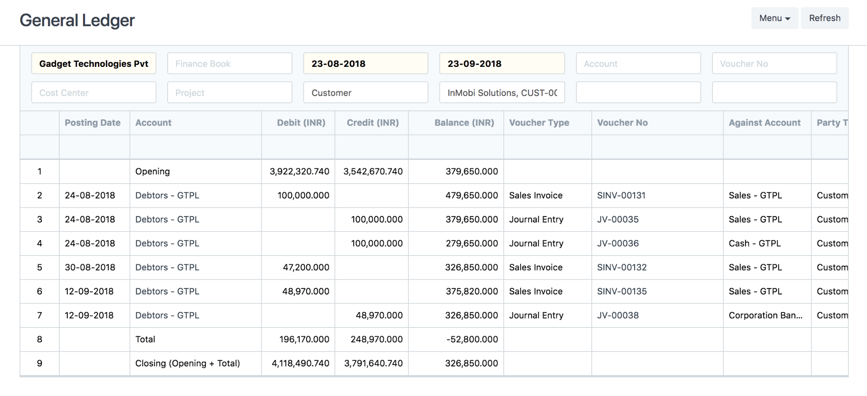

* **Accounts Receivable:**
  + **Sales Invoices:**
    - A Sales Invoice is a bill that you send to your Customers against which the Customer makes the payment.

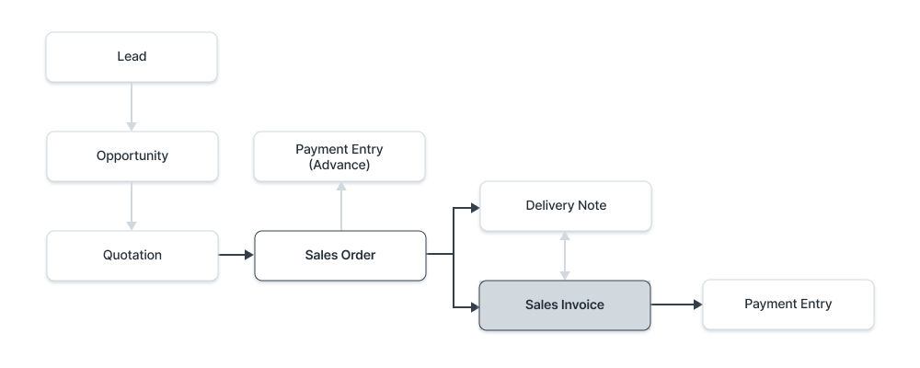

* + - A Sales Invoice is usually created from a Sales Order or a Delivery Note. The Customer's Item details will be fetched into the Sales Invoice. However, you can also create a Sales Invoice directly, for example, a POS invoice.
    - To create Sales Invoice:

| Label (Fields) | Type (Fields) | Mandatory (Fields) | Options (Fields) |
| --- | --- | --- | --- |
| Title | Data | 0 |  |
| Customer | Link | 0 | Customer |
| Customer Name | Small Text | 0 |  |
| Tax Id | Data | 0 |  |
| POS Profile | Link | 0 | POS Profile |
| Include Payment (POS) | Check | 0 |  |
| Is Consolidated | Check | 0 |  |
| Is Return (Credit Note) | Check | 0 |  |
| Is Rate Adjustment Entry (Debit Note) | Check | 0 |  |
| Update Billed Amount in Sales Order | Check | 0 |  |
| Company | Link | 1 | Company |
| Company Tax ID | Data | 0 |  |
| Date | Date | 1 |  |
| Posting Time | Time | 0 |  |
| Edit Posting Date and Time | Check | 0 |  |
| Payment Due Date | Date | 0 |  |
| Return Against | Link | 0 | Sales Invoice |
| Amended From | Link | 0 | Sales Invoice |
| Project | Link | 0 | Project |
| Cost Center | Link | 0 | Cost Center |
| Customer's Purchase Order | Data | 0 |  |
| Customer's Purchase Order Date | Date | 0 |  |
| Customer Address | Link | 0 | Address |
| Address | Small Text | 0 |  |
| Contact Person | Link | 0 | Contact |
| Contact | Small Text | 0 |  |
| Mobile No | Small Text | 0 |  |
| Contact Email | Data | 0 | Email |
| Territory | Link | 0 | Territory |
| Shipping Address Name | Link | 0 | Address |
| Shipping Address | Small Text | 0 |  |
| Company Address Name | Link | 0 | Address |
| Company Address | Small Text | 0 |  |
| Dispatch Address Name | Link | 0 | Address |
| Dispatch Address | Small Text | 0 |  |
| Currency | Link | 1 | Currency |
| Exchange Rate | Float | 1 |  |
| Price List | Link | 1 | Price List |
| Price List Currency | Link | 1 | Currency |
| Price List Exchange Rate | Float | 1 |  |
| Ignore Pricing Rule | Check | 0 |  |
| Source Warehouse | Link | 0 | Warehouse |
| Set Target Warehouse | Link | 0 | Warehouse |
| Update Stock | Check | 0 |  |
| Scan Barcode | Data | 0 | Barcode |
| Items | Table | 1 | Sales Invoice Item |
| Pricing Rule Detail | Table | 0 | Pricing Rule Detail |
| Packed Items | Table | 0 | Packed Item |
| Product Bundle Help | HTML | 0 |  |
| Time Sheets | Table | 0 | Sales Invoice Timesheet |
| Total Billing Amount | Currency | 0 | currency |
| Total Billing Hours | Float | 0 |  |
| Total Quantity | Float | 0 |  |
| Total (Company Currency) | Currency | 0 | Company:company:default_currency |
| Net Total (Company Currency) | Currency | 1 | Company:company:default_currency |
| Total Net Weight | Float | 0 |  |
| Total | Currency | 0 | currency |
| Net Total | Currency | 0 | currency |
| Sales Taxes and Charges Template | Link | 0 | Sales Taxes and Charges Template |
| Shipping Rule | Link | 0 | Shipping Rule |
| Tax Category | Link | 0 | Tax Category |
| Sales Taxes and Charges | Table | 0 | Sales Taxes and Charges |
| Taxes and Charges Calculation | Long Text | 0 |  |
| Total Taxes and Charges (Company Currency) | Currency | 0 | Company:company:default_currency |
| Total Taxes and Charges | Currency | 0 | currency |
| Loyalty Points | Int | 0 |  |
| Loyalty Amount | Currency | 0 | Company:company:default_currency |
| Redeem Loyalty Points | Check | 0 |  |
| Loyalty Program | Link | 0 | Loyalty Program |
| Redemption Account | Link | 0 | Account |
| Redemption Cost Center | Link | 0 | Cost Center |
| Apply Additional Discount On | Select | 0 | Grand Total  Net Total |
| Is Cash or Non Trade Discount | Check | 0 |  |
| Additional Discount Amount (Company Currency) | Currency | 0 | Company:company:default_currency |
| Discount Account | Link | 0 | Account |
| Additional Discount Percentage | Float | 0 |  |
| Additional Discount Amount | Currency | 0 | currency |
| Grand Total (Company Currency) | Currency | 1 | Company:company:default_currency |
| Rounding Adjustment (Company Currency) | Currency | 0 | Company:company:default_currency |
| Rounded Total (Company Currency) | Currency | 0 | Company:company:default_currency |
| In Words (Company Currency) | Small Text | 0 |  |
| Grand Total | Currency | 1 | currency |
| Rounding Adjustment | Currency | 0 | currency |
| Rounded Total | Currency | 0 | currency |
| In Words | Small Text | 0 |  |
| Total Advance | Currency | 0 | party_account_currency |
| Outstanding Amount | Currency | 0 | party_account_currency |
| Disable Rounded Total | Check | 0 |  |
| Write Off Amount | Currency | 0 | currency |
| Write Off Amount (Company Currency) | Currency | 0 | Company:company:default_currency |
| Write Off Outstanding Amount | Check | 0 |  |
| Write Off Account | Link | 0 | Account |
| Write Off Cost Center | Link | 0 | Cost Center |
| Allocate Advances Automatically (FIFO) | Check | 0 |  |
| Get Advances Received | Button | 0 | set_advances |
| Advances | Table | 0 | Sales Invoice Advance |
| Ignore Default Payment Terms Template | Check | 0 |  |
| Payment Terms Template | Link | 0 | Payment Terms Template |
| Payment Schedule | Table | 0 | Payment Schedule |
| Cash/Bank Account | Link | 0 | Account |
| Sales Invoice Payment | Table | 0 | Sales Invoice Payment |
| Paid Amount (Company Currency) | Currency | 0 | Company:company:default_currency |
| Paid Amount | Currency | 0 | currency |
| Base Change Amount (Company Currency) | Currency | 0 | Company:company:default_currency |
| Change Amount | Currency | 0 | currency |
| Account for Change Amount | Link | 0 | Account |
| Terms | Link | 0 | Terms and Conditions |
| Terms and Conditions Details | Text Editor | 0 |  |
| Letter Head | Link | 0 | Letter Head |
| Group same items | Check | 0 |  |
| Print Heading | Link | 0 | Print Heading |
| Print Language | Data | 0 |  |
| Status | Select | 0 | Draft  Return  Credit Note Issued  Submitted  Paid  Partly Paid  Unpaid  Unpaid and Discounted  Partly Paid and Discounted  Overdue and Discounted  Overdue  Cancelled  Internal Transfer |
| Inter Company Invoice Reference | Link | 0 | Purchase Invoice |
| Represents Company | Link | 0 | Company |
| Customer Group | Link | 0 | Customer Group |
| Campaign | Link | 0 | Campaign |
| Is Internal Customer | Check | 0 |  |
| Is Discounted | Check | 0 |  |
| Source | Link | 0 | Lead Source |
| Debit To | Link | 1 | Account |
| Party Account Currency | Link | 0 | Currency |
| Is Opening Entry | Select | 0 | No  Yes |
| C-Form Applicable | Select | 0 | No  Yes |
| C-Form No | Link | 0 | C-Form |
| Unrealized Profit / Loss Account | Link | 0 | Account |
| Remarks | Small Text | 0 |  |
| Sales Partner | Link | 0 | Sales Partner |
| Amount Eligible for Commission | Currency | 0 |  |
| Commission Rate (%) | Float | 0 |  |
| Total Commission | Currency | 0 | Company:company:default_currency |
| Sales Contributions and Incentives | Table | 0 | Sales Team |
| From Date | Date | 0 |  |
| To Date | Date | 0 |  |
| Auto Repeat | Link | 0 | Auto Repeat |
| Update Auto Repeat Reference | Button | 0 |  |
| Against Income Account | Small Text | 0 |  |

* + **Customer :**
    - A customer, who is sometimes known as a client, buyer, or purchaser, is the one who receives goods, services, products, or ideas, from a seller for monetary consideration.
    - Customer Screen shall have the following fields:

| Label (Fields) | Type (Fields) | Mandatory (Fields) | Options (Fields) |
| --- | --- | --- | --- |
| Salutation | Link | 0 | Salutation |
| Full Name | Data | 1 |  |
| Gender | Link | 0 | Gender |
| Type | Select | 1 | Company  Individual |
| PAN | Data | 0 |  |
| Tax Withholding Category | Link | 0 | Tax Withholding Category |
| Default Company Bank Account | Link | 0 | Bank Account |
| From Lead | Link | 0 | Lead |
| From Opportunity | Link | 0 | Opportunity |
| Image | Attach Image | 0 |  |
| Account Manager | Link | 0 | User |
| Customer Group | Link | 1 | Customer Group |
| Territory | Link | 1 | Territory |
| Tax ID | Data | 0 |  |
| Tax Category | Link | 0 | Tax Category |
| Allow Sales Invoice Creation Without Sales Order | Check | 0 |  |
| Allow Sales Invoice Creation Without Delivery Note | Check | 0 |  |
| Disabled | Check | 0 |  |
| Is Internal Customer | Check | 0 |  |
| Represents Company | Link | 0 | Company |
| Allowed To Transact With | Table | 0 | Allowed To Transact With |
| Billing Currency | Link | 0 | Currency |
| Default Price List | Link | 0 | Price List |
| Address HTML | HTML | 0 |  |
| Website | Data | 0 |  |
| Contact HTML | HTML | 0 |  |
| Customer Primary Contact | Link | 0 | Contact |
| Mobile No | Read Only | 0 |  |
| Email Id | Read Only | 0 |  |
| Customer Primary Address | Link | 0 | Address |
| Primary Address | Text | 0 |  |
| Accounts | Table | 0 | Party Account |
| Default Payment Terms Template | Link | 0 | Payment Terms Template |
| Credit Limit | Table | 0 | Customer Credit Limit |
| Customer Details | Text | 0 |  |
| Market Segment | Link | 0 | Market Segment |
| Industry | Link | 0 | Industry Type |
| Print Language | Link | 0 | Language |
| Is Frozen | Check | 0 |  |
| Loyalty Program | Link | 0 | Loyalty Program |
| Loyalty Program Tier | Data | 0 |  |
| Sales Partner | Link | 0 | Sales Partner |
| Commission Rate | Float | 0 |  |
| Sales Team Details | Table | 0 | Sales Team |
| Customer POS id | Data | 0 |  |

* + - * Flow -:

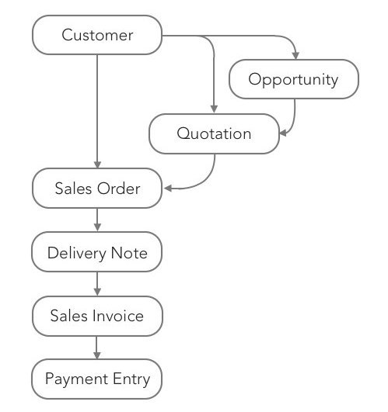

* + **Payment Entry :**
    - A Payment Entry is a record indicating that payment has been made for an invoice.
    - Payment Entry can be made against the following transactions.
* Sales Invoice
* Purchase Invoice
* Sales Order (Advance Payment)
* Purchase Order (Advance Payment)
* Expense Claim
* Internal Transfer
  + - Here are diagrams to understand the flow:
      * In Sales:-

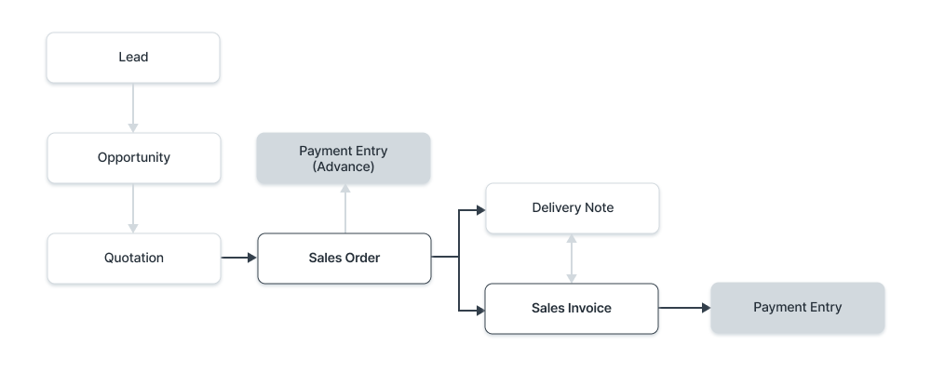

* + - * In Purchase :-

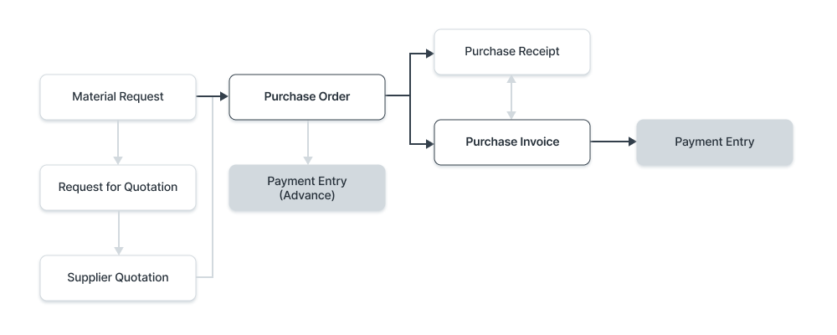

* + - Payment Entry Shall have the following fields :-
      * Posting Date
      * The Payment Type will be set based on the transaction you're coming from. The types are 'Receive', 'Pay', and 'Internal Transfer'.
      * The Party Type, Party, Party Name will be fetched automatically.
      * The Account Paid To and Account Paid From will be fetched as set in the Company.
      * The Amount Paid will be fetched from the Invoice.
* **Accounts Payable :-** 
  + **Purchase Invoice :-**
    - A Purchase Invoice is a bill you receive from your Suppliers against which you need to make the payment.
    - Purchase Invoice is the exact opposite of your Sales Invoice. Here you accrue expenses to your Supplier. Making a Purchase Invoice is very similar to making a Purchase Order.

| Field Name | Field Type | Mandatory | Links |
| --- | --- | --- | --- |
| Title | Data | Yes |  |
| Supplier | Link | Yes | Supplier |
| Company | Link | Yes | Company |
| Date | Date | Yes |  |
| Cost Center | Link | Yes | Cost Center |
| Items | Table | Yes | Purchase Invoice Item |
| Supplier Invoice No | Data | No |  |
| Supplier Invoice Date | Date | No |  |
| Scan Barcode | Data | No | Barcode |
| Item | Table | No | Purchase Invoice Item |
| Pricing Rule Detail | Table | No | Pricing Rule Detail |
| Supplied Items | Table | No | Purchase Receipt Item Supplied |
| Total Quantity | Float | No |  |
| Net Total (Company Currency) | Currency | No |  |
| Tax Category | Link | No | Tax Category |
| Mode of Payment | Link | No | Mode of Payment |
| Cash/Bank Account | Link | No | Account |
| Party Account Currency | Link | No | Currency |

* + **Supplier:-** 
    - Suppliers are companies or individuals who provide you with products or services.
    - Supplier fields shall have following fields in a tabular format:

| Field Name | Field Type | Mandatory | Links |
| --- | --- | --- | --- |
| Supplier Name | Data | Yes |  |
| Country | Link | No | Country |
| Tax ID | Data | No |  |
| Tax Category | Link | No | Tax Category |
| Supplier Group | Link | Yes | Supplier Group |
| Supplier Type | Select | Yes | -Company  -Individual |
| Allowed To Transact With | Table | No | Allowed To Transact With |
| Billing Currency | Link | No | Currency |
| Price List | Link | No | Price List |
| Default Payment Terms Template | Link | No | Payment Terms Template |
| Address HTML | HTML | No |  |
| Supplier Primary Contact | Link | No | Contact |

# **Accounting Reports**

Some of the major accounting reports are:

## **Accounting Statements**

## **Accounts Receivable and Accounts Payable (AR / AP)**

These reports help you to track the outstanding amount of Customers and Suppliers. It also provides aging analysis i.e. a break-up of outstanding amounts based on the period for which the amount is outstanding.

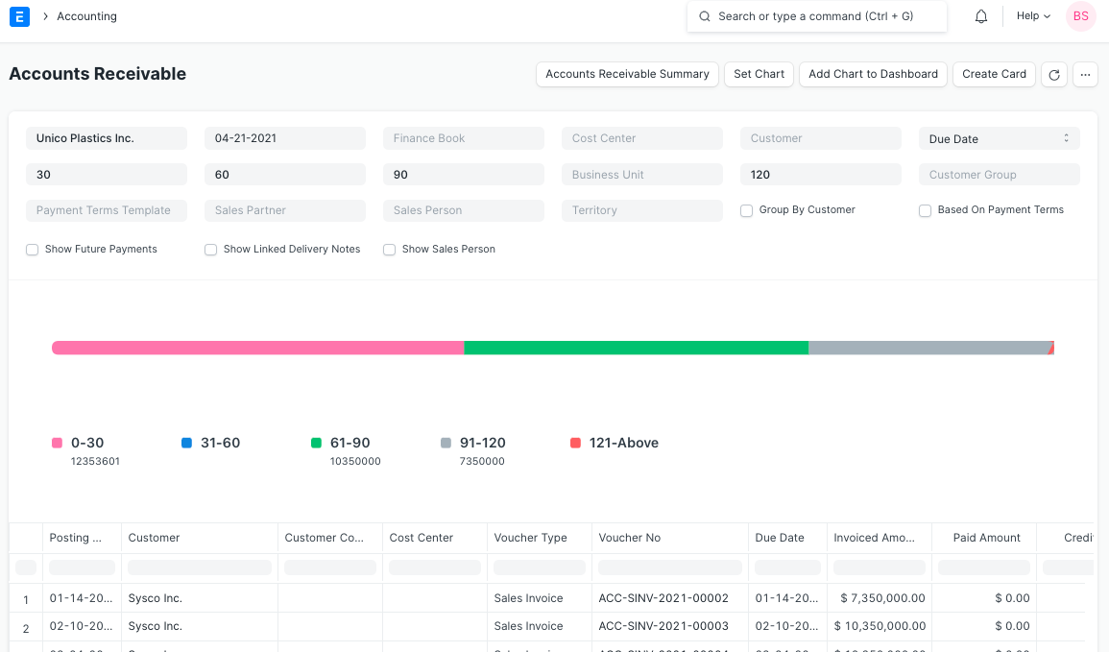

## 

## **Accounts Receivables based on Payment terms**

You can also see Accounts Receivables based on Payment Terms

Accounts Receivable report based on payment terms can be seen by clicking the checkbox 'Based On Payment Terms' as shown in the following screenshot.

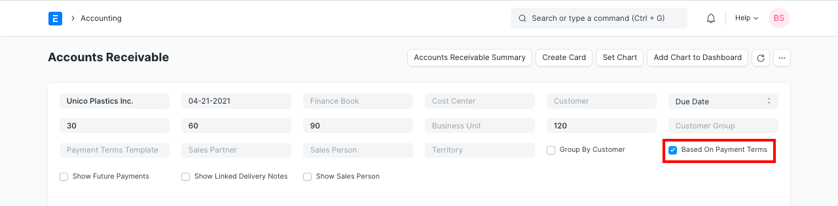

Outstanding amounts against each payment term can be seen. **Invoiced Amount** shows each payment term amount and **Paid Amount** shows paid amount against each payment term. Payment against each term is allocated in FIFO order.

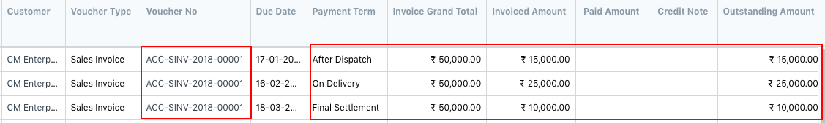

### **2.2 Trial Balance** A Trial Balance is an accounting report which lists account balances for all your Accounts (“Ledger” and “Group”) for any given reporting period. A company prepares a trial balance periodically, usually at the end of every reporting period. The general purpose of producing a trial balance is to ensure the entries in a company's bookkeeping system are mathematically correct. The totals of Debit and Credit columns must be the same for any given period, to ensure the entries are correct. Here, the report shows following columns:

* Opening (Dr): Opening debit balance as on From Date
* Opening (Cr): Opening credit balance as on From Date
* Debit: Total Debited amount against the account between the selected period
* Credit: Total Credited amount against the account between the selected period
* Closing (Dr): Closing debit balance as on To Date
* Closing (Cr): Closing credit balance as on To Date

There are some other options as well to include or exclude Period Closing Entries, show / hide accounts with zero balance and to show unclosed previous fiscal year's P&L (Income & Expenses) balances. All the figures in the report are shown in the company's base currency.

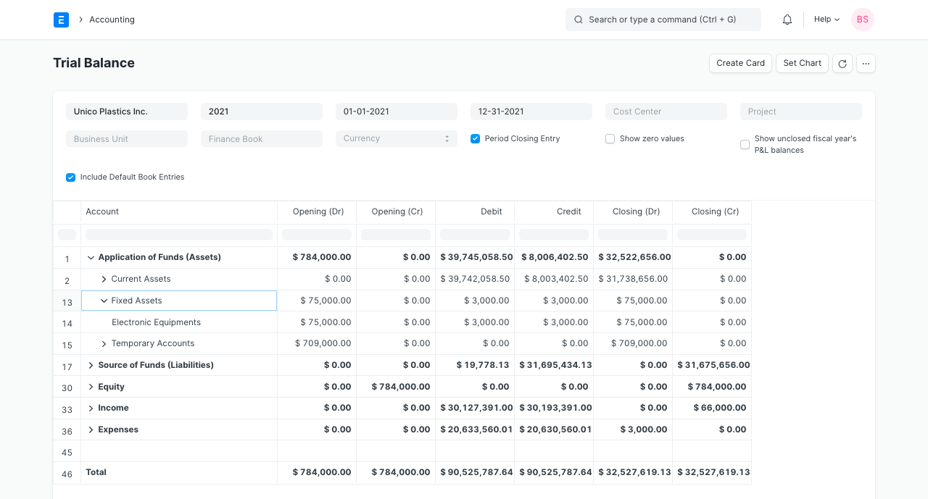

### **2.3 Balance Sheet**

A Balance Sheet is the financial statement of a company which states assets, liabilities and equity at a particular point in time.

The Balance Sheet gives you more flexibility to analyze your financial position. You can run the report across multiple years to compare values. You can check values for a specific Finance Book or Cost Center. You can also choose any other currency to display the balances.

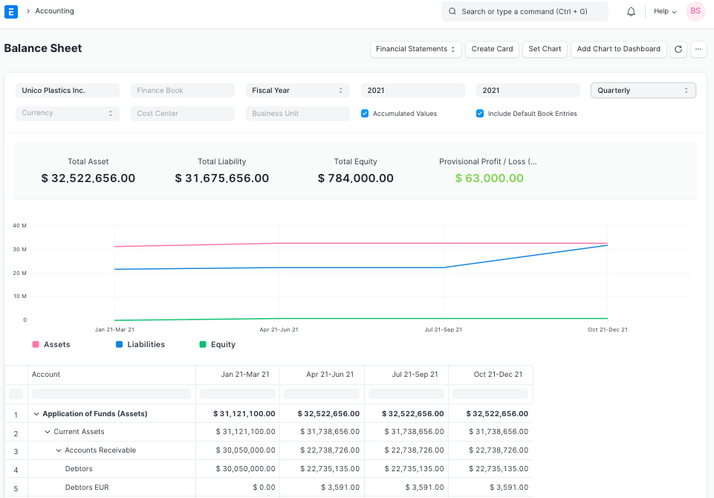

### **2.4 Cash Flow Statement**

### A Cash Flow is a financial statement which shows the incoming and outgoing cash or cash-equivalents for a company. It is used to analyze the liquidity position of the company.

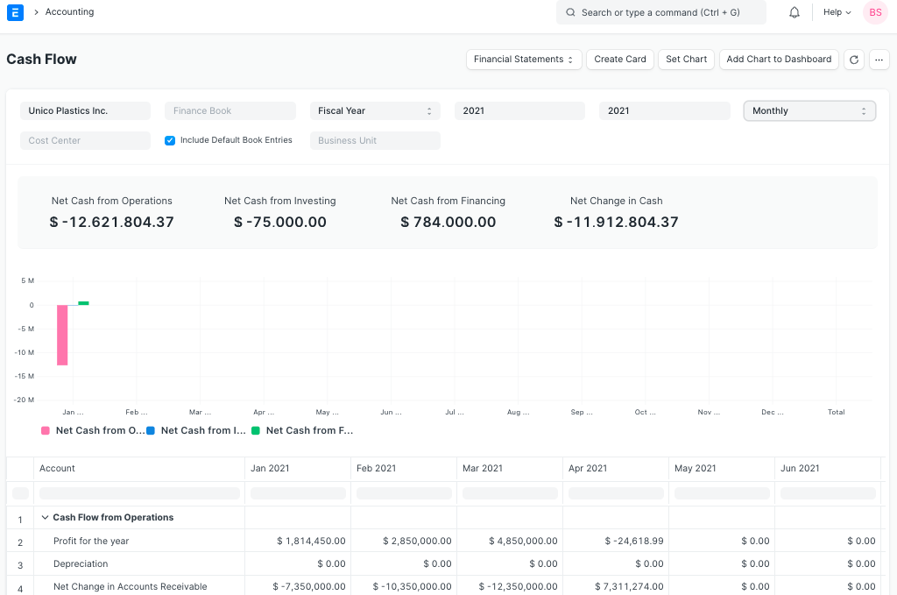

### **2.5 Profit and Loss Statement**

A Profit and Loss Statement is a financial statement which summarizes all the revenues and expenses in a given period. The report is also known as P&L Statement.

Here, you can run the report across multiple years / periods to compare the values. You can also check values for a specific Finance Book, Project or Cost Center. You can also choose any other currency to display the balances. If you are running the report to see quarterly / monthly balances, you can choose whether you want to show accumulated balances or only for each period.

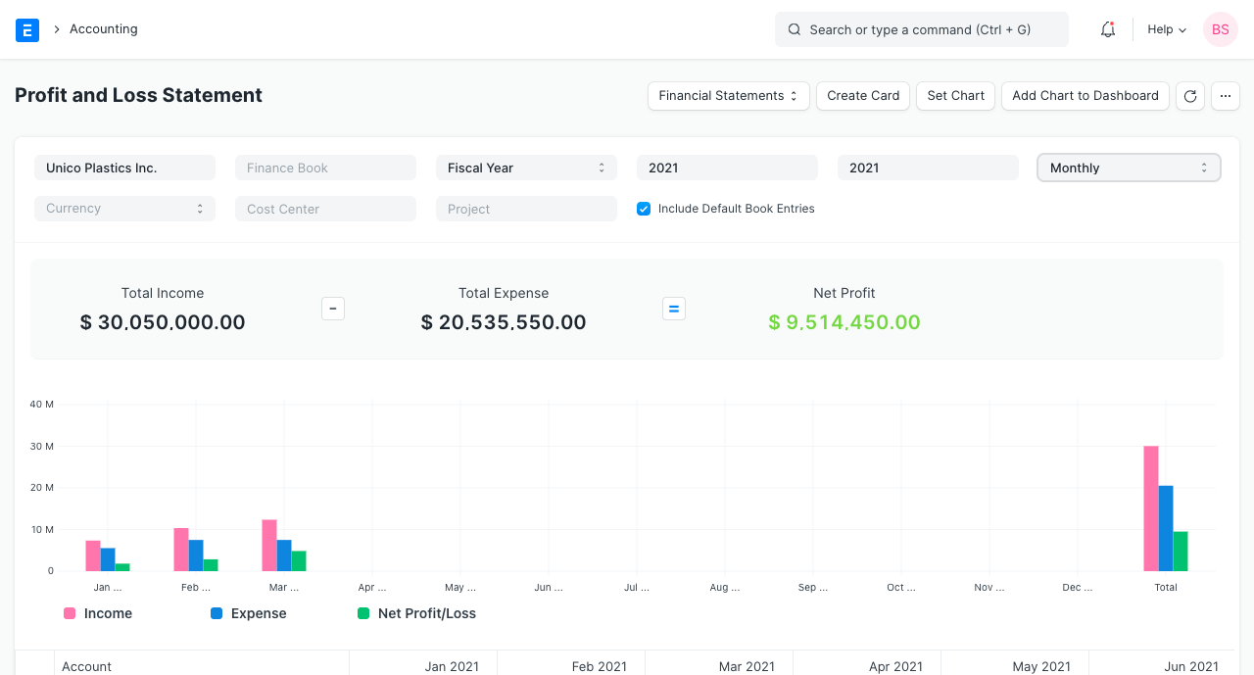

### **2.6 Consolidated Financial Statements**

### The report shows a consolidated view of Balance Sheet, Profit and Loss Statement and Cash Flow for a group company, by merging financial statements of all the subsidiary companies. It shows balances for all individual companies and as well as accumulated balances for a group company.

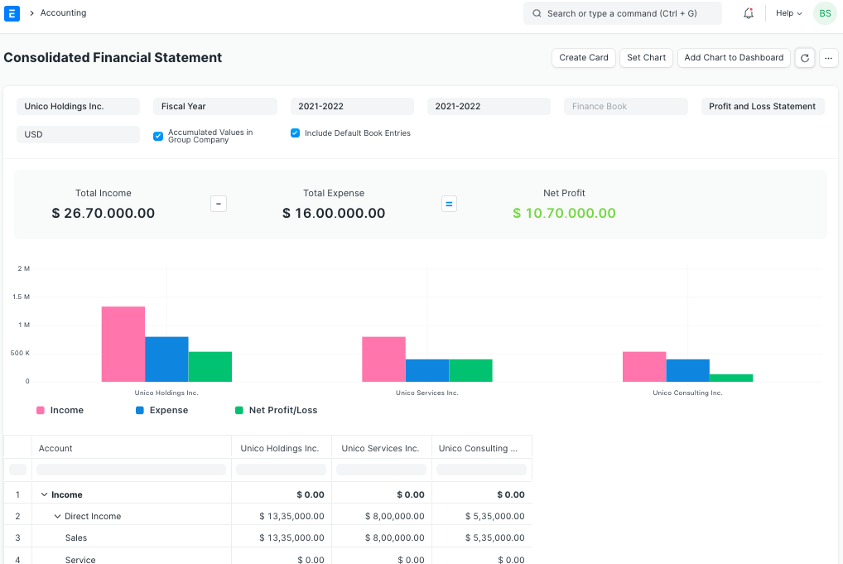

## **3. Taxes**

## **3.1 Sales and Purchase Register**

## The Sales and Purchase Register report shows all the Sales and Purchase transactions for a given period with invoiced amount and tax details. In this report, each tax has a separate column, so you can easily get total taxes collected / paid for a period for each individual tax type, which helps to pay the taxes to the government.

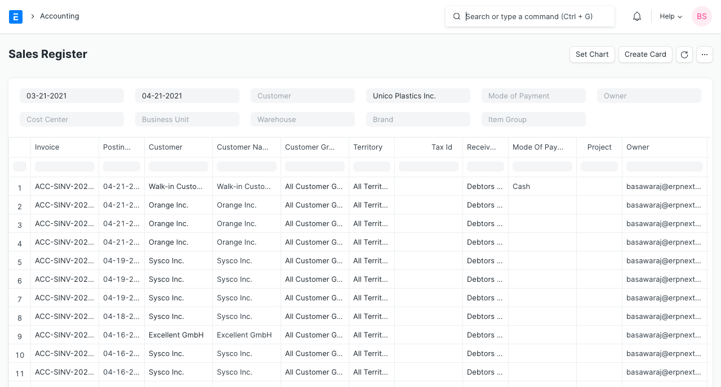

## **4. Budget and Cost Center**

## **4.1 Budget Variance**

## Here, you can assign an expense budget for an expense account against any specific cost center. This report gives a comparison between budgeted and actual expenses and the variance (the difference between the two) in monthly / quarterly / yearly view.

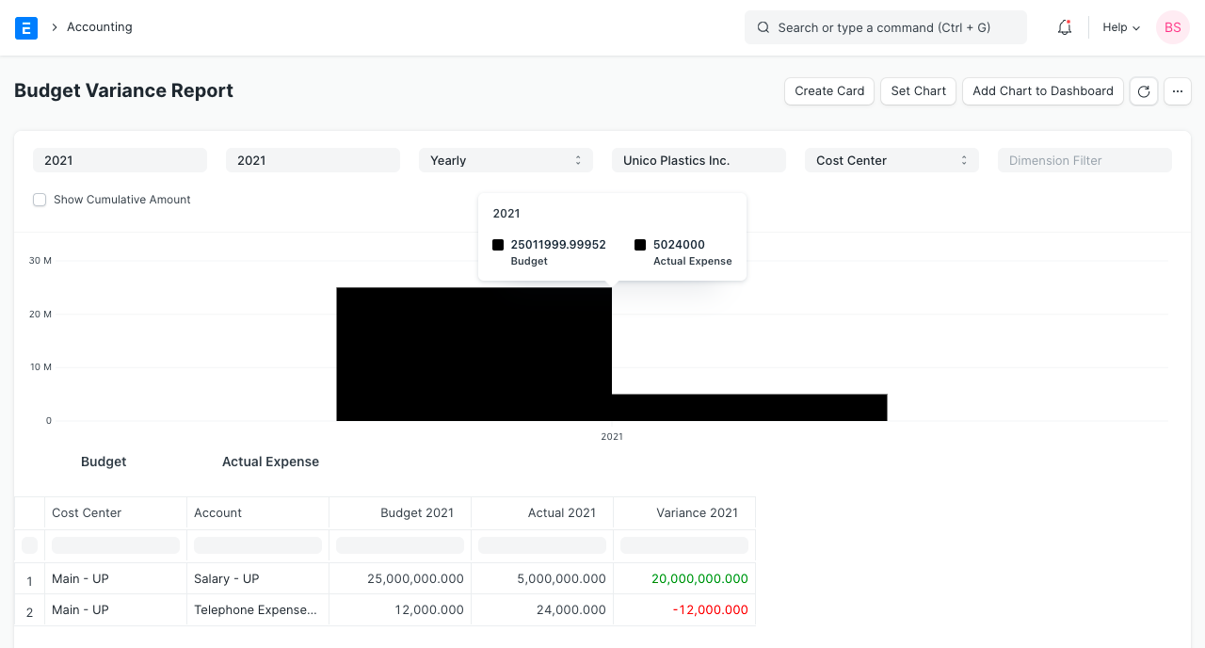

## **5. Tax reports for India**

## **5.1 GSTR-1 (India)**

## The GSTR-1 report helps Indian users to file monthly returns of outward supplies. This report shows all the sales transactions of the company in Govt specified format. The output of the report is changed based on the selected type of business (B2B, B2C Large, B2C Small, CDNR and Export).

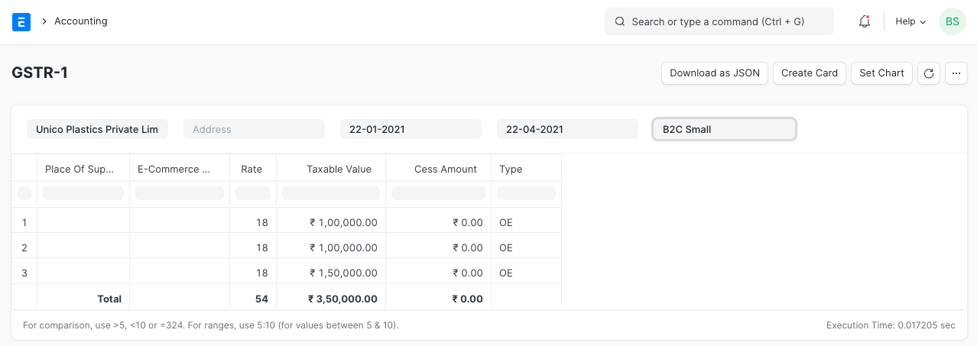

### **5.2 GSTR-2 (India)**

### The GSTR-2 report helps Indian users to file monthly returns of inward supplies. The report gives the details of all inward supplies of goods or services received during a month, in Govt specified format.

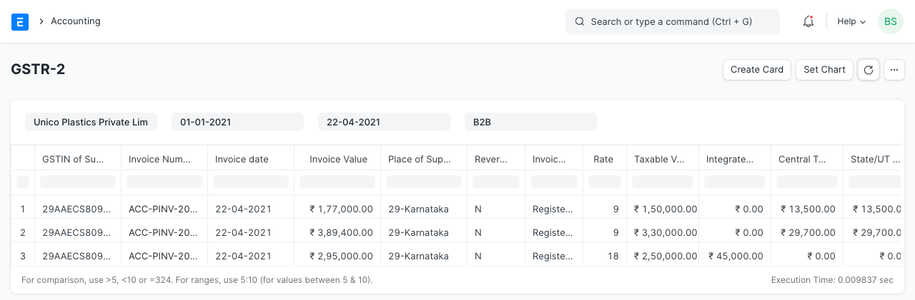

## **6. Analytics**

### **6.1 Item wise Sales and Purchase Register**

### **Purchase Register**.

The Item Wise Sales and Purchase Register report shows all the Sales and Purchase transactions for a given period with item rate, quantity, amount and tax details. In this report, taxes have a separate column, so you can easily get individual taxes for each individual item. From this report you can have a look of which items are sold or purchased most.

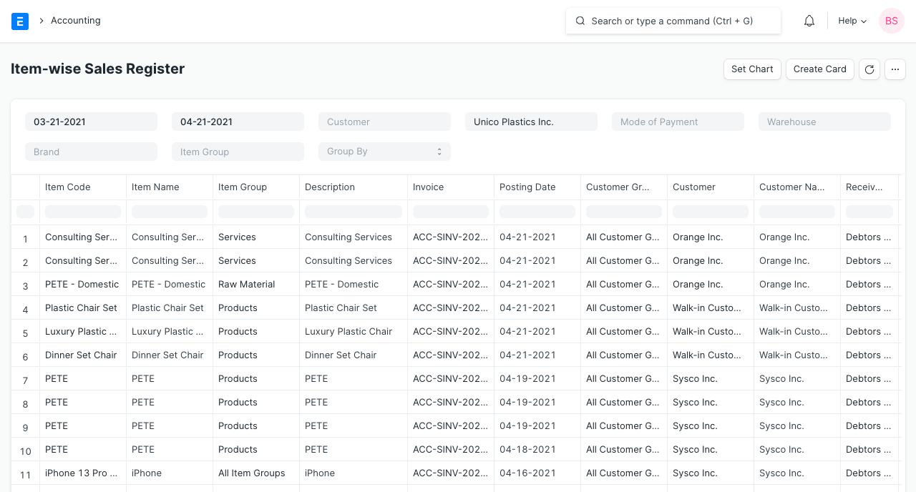

More detailed analysis can also be done by using the 'Group By' filter which gives sales data for a specific Customer, Supplier, Territory, etc. You can find out which Item is more popular in which region or which Customer is buying which Item more.

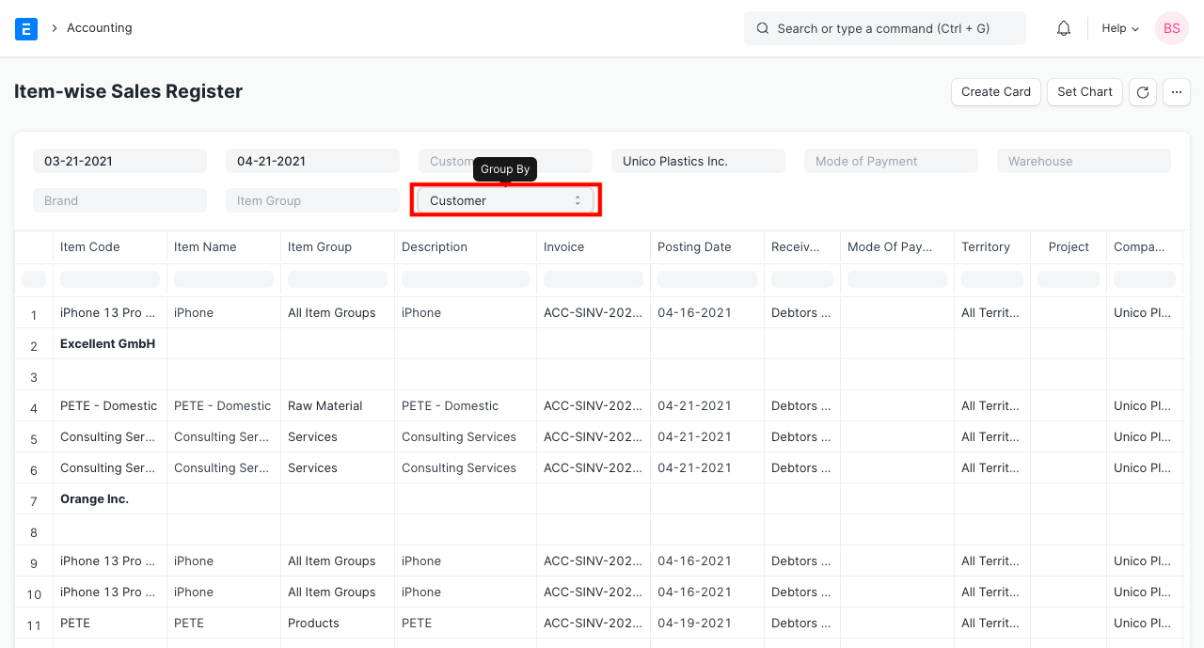

### **6.2 Sales or Purchase Invoice Trends**

### Another very useful report is invoice trends. From this report you can easily get the trending items on a monthly, quarterly, half yearly or yearly basis. You will get the idea of sales and purchase both in quantity and amount.

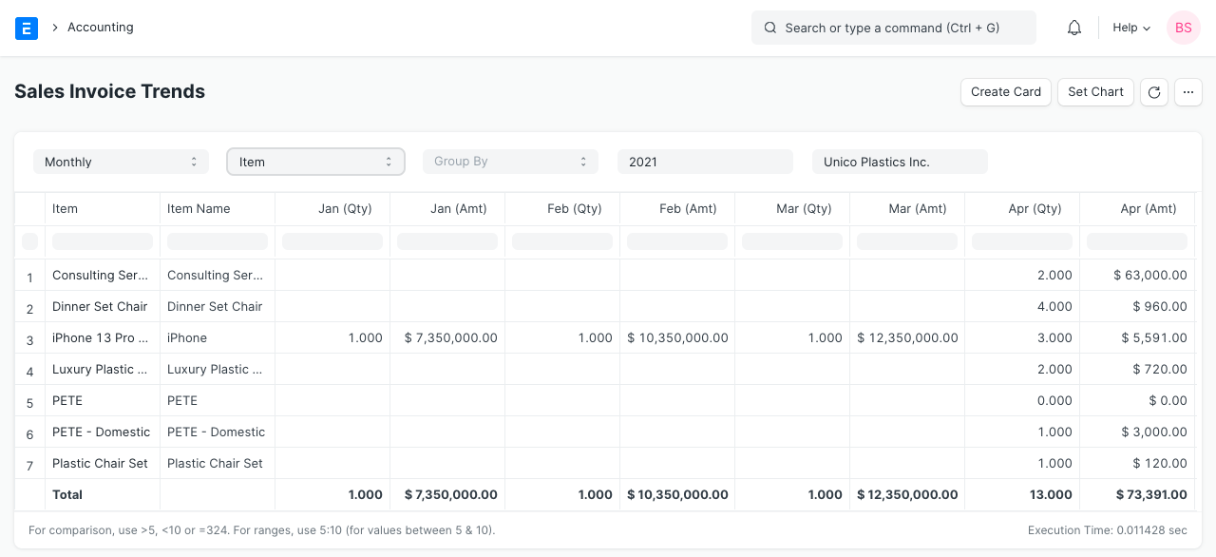

## **7. To Bill**

## **Ordered Items To Be Billed:** The report shows the items which have been ordered by customers, against which Sales Invoice has not been created / partially been created.

* **Delivered Items To Be Billed:** The items which have been delivered to the customers, but Sales Invoice has not been created / partially been created.
* **Purchase Order Items To Be Billed:** The report shows the items which have been ordered from the suppliers, but Purchase Invoice has not been created / partially been created.
* **Received Items To Be Billed:** The items which has been received from the suppliers, but Purchase Invoice has not been created / partially been created.

## **8. Other Reports**

## **8.1 Party Wise Trial Balance**

## Usually you might need to see the trial balance for your customers and suppliers. You can easily get for all of your customers or suppliers and also for individuals.

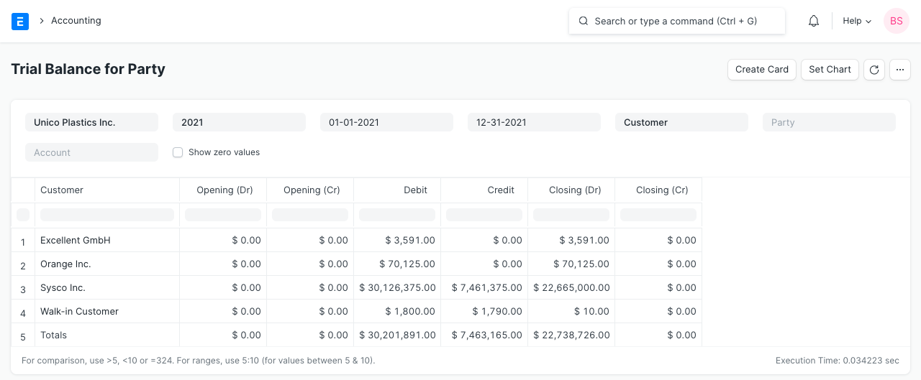

### **8.2 Customer Credit Balance**

### The report shows the credit limit, outstanding and credit balance for each customer.

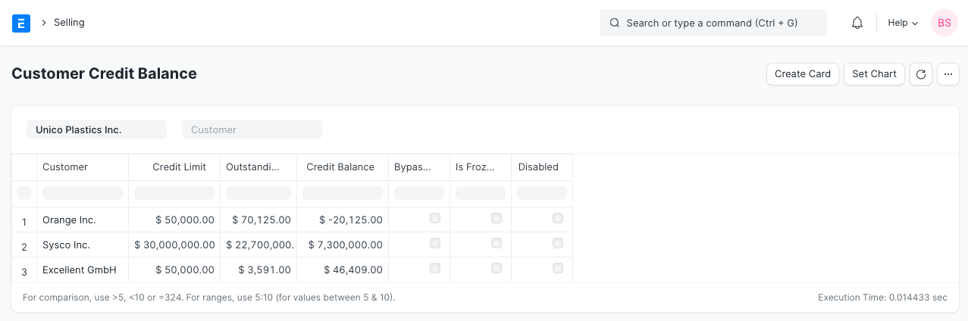

* **Multi Currency:-**
  + **Currency :**
    - The Currency list stores the currency value, its symbol and fraction unit. Most of the commonly used currencies are already here. The exchange rates are fetched automatically according to the current market rate.
    - Currency shall have the following fields:-

| **Field Name** | **Type** | **Link** | **Mandatory** |
| --- | --- | --- | --- |
| Currency Name | Data |  | 1 |
| Enabled | Check |  | 0 |
| Fraction | Data |  | 0 |
| Fraction Units | Int |  | 0 |
| Smallest Currency Fraction Value | Currency |  | 0 |
| Symbol | Data |  | 0 |

* + **Currency Exchange:-**
    - The Currency Exchange form stores exchange rates manually stored by the User. By default, it automatically fetched the current exchange rates for currencies as per the market. However, you can store fixed exchange rates and use them. You need to enable 'Allow Stale Exchange Rates' in Accounts Settings for using the exchange rates stored in the Currency Exchange form.
    - Currency Exchange shall have the following fields:-

| **Field Name** | **Type** | **Link** | **Mandatory** |
| --- | --- | --- | --- |
| Date | Data |  | 1 |
| From Currency | Link | Currency | 1 |
| To Currency | Link | Currency | 1 |
| Exchange Rate | Float |  | 1 |
| For Buying | Select |  | 0 |
| For Selling | Select |  | 0 |

* + **Exchange Rate Revaluation :-**
    - You can make accounting entries in multiple currencies. For example, if you have a bank account in a foreign currency, you can make transactions in that currency and the system will show bank balance in that specific currency.
    - The purpose of Exchange Rate Revaluation master is to adjust the balance in General Ledger accounts according to any changes in the currency exchange rates. This is useful when you are closing your accounts books and want to update your Company's GL accounts by bringing in the money from other currency accounts.
    - Exchange Rate Revaluation shall have the following fields:

| **Field Name** | **Type** | **Link** | **Mandatory** |
| --- | --- | --- | --- |
| Posting Date | Data |  | 1 |
| Company | Link | Company | 1 |
| Exchange Rate Revaluation Account | Table | Exchange Rate Revaluation Account | 0 |

* **Banking and Payments:**
  + **Bank :-**
    - Saving different banks lets you upload an excel sheet and map the transactions to the ledger. The transactions are created as Bank Transactions. These can then be used for reference and reports. This is done usingBank Reconciliation.
    - Bank shall have the following fields:

| Field Name | Type | Link | Mandatory |
| --- | --- | --- | --- |
| Bank Name | Data |  | 1 |
| SWIFT number | Data |  | 0 |
| Website | Data |  | 0 |
| Address HTML | HTML |  | 0 |
| Contact HTML | HTML |  | 0 |
| Bank Transaction Mapping | Table | Bank transaction Mapping | 0 |
| Plaid Access Token | Data |  | 0 |

* + **Bank Account:**
    - Bank Accounts can be created for a Company as well as other parties like Customers, Suppliers etc. Doing this lets you record all the bank transactions correctly for accounting accuracy.
    - You can add Bank Accounts for Company. Supplier, Customer, or any other party with whom transactions are carried out. Then the Bank Account can be chosen inPayment Entries as Mode of Payment.
    - Bank Account Shall have the following fields:

| Field Name | Type | Link | Mandatory |
| --- | --- | --- | --- |
| Account Name | Data |  | 1 |
| Company Account | Link | Account | 0 |
| Bank | Link | Bank | 1 |
| Account Type | Link | Bank Account Type | 0 |
| Account Subtype | Link | Bank Account Subtype | 0 |
| Is Default Account | Check |  | 0 |
| Is Company Account | Check |  | 0 |
| Company | Link | Company | 0 |
| Party Type | Link | DocType | 0 |
| Party | Dynamic Link | party_type | 0 |
| IBAN | Data |  | 0 |
| Branch Code | Data |  | 0 |
| Bank Account No | Data |  | 0 |
| Address HTML | HTML |  | 0 |
| Website | Data |  | 0 |
| Contact HTML | HTML |  | 0 |
| Integration ID | Data |  | 0 |
| Last Integration Date | Date |  | 0 |
| Mask | Data |  | 0 |

* + **Bank Clearance:-**
    - Clearing in the banking system is the process of settling transactions between banks. Millions of transactions occur every day, so bank clearing tries to minimize the amounts that change hands on a given day.
    - Bank Clearance shall have the following fields:

| Field Name | Type | Link | Mandatory |
| --- | --- | --- | --- |
| Account Currency | Link | Currency | 0 |
| From Date | Date |  | 1 |
| To Date | Date |  | 1 |
| Bank Account | Link | Bank Account | 0 |
| Include Reconciled Entries | Check |  | 0 |
| Include POS Transactions | Check |  | 0 |
| Get Payment Entries | Button |  | 0 |
| Payment Entries | Table | Bank Clearance Detail | 0 |
| Update Clearance Date | Button |  | 0 |
| Total Amount | Currency | account_currency | 0 |

* + **Payment Reconciliation:**
    - **Payment Reconciliation is used to link payments with invoices.**
    - In complex scenarios, especially in the capital goods industry, sometimes there is no direct link between payments and invoices. You send invoices to your Customers and your Customer sends you block payments or payments based on some schedule that is not linked to your invoices.
    - In such cases, you can match Payments with Invoices using Payment Reconciliation.
    - Payment Reconciliation shall have the following fields:

| Label (Fields) | Type (Fields) | Options (Fields) | Mandatory (Fields) |
| --- | --- | --- | --- |
| Company | Link | Company | 1 |
| Party Type | Link | DocType | 1 |
| Party | Dynamic Link | party_type | 1 |
| Receivable / Payable Account | Link | Account | 1 |
| From Invoice Date | Date |  | 0 |
| From Payment Date | Date |  | 0 |
| Minimum Invoice Amount | Currency |  | 0 |
| Minimum Payment Amount | Currency |  | 0 |
| To Invoice Date | Date |  | 0 |
| To Payment Date | Date |  | 0 |
| Maximum Invoice Amount | Currency |  | 0 |
| Maximum Payment Amount | Currency |  | 0 |
| Invoice Limit | Int |  | 0 |
| Payment Limit | Int |  | 0 |
| Bank / Cash Account | Link | Account | 0 |
| Cost Center | Link | Cost Center | 0 |
| Invoices | Table | Payment Reconciliation Invoice | 0 |
| Payments | Table | Payment Reconciliation Payment | 0 |
| Allocation | Table | Payment Reconciliation Allocation | 0 |

* **Subscription Management**
  + **Subscription Plan :**
    - A Subscription Plan stores information about the Item being subscribed, its price, and billing interval.
    - Subscription Plan shall have the following fields:

| Label (Fields) | Type (Fields) | Options (Fields) | Mandatory (Fields) |
| --- | --- | --- | --- |
| Plan Name | Data |  | 1 |
| Currency | Link | Currency | 0 |
| Item | Link | Item | 1 |
| Subscription Price Based On | Select | Fixed Rate  Based On Price List  Monthly Rate | 1 |
| Cost | Currency | currency | 0 |
| Price List | Link | Price List | 0 |
| Billing Interval | Select | Day  Week  Month  Year | 1 |
| Billing Interval Count | Int |  | 1 |
| Product Price ID | Data |  | 0 |
| Payment Gateway | Link | Payment Gateway Account | 0 |
| Cost Center | Link | Cost Center | 0 |

* + **Subscription:**
    - If you offer a service that requires renewal in a certain time period or you pay some monthly expenses like rent (yearly, monthly, quarterly, etc.), you can use the Subscription feature here to track them. The Subscription master captures all the details required for the auto-creation of Sales or Purchase Invoices.
    - Our hosting plans are available on a yearly basis. Each Customer's account has a subscription expiry date, after which customers must renew their subscription with us.
    - To manage the client's subscription expiry and auto-generation of Sales Invoice for the renewal, we use the Subscription feature.
    - Subscription shall have the following fields:

| Label (Fields) | Type (Fields) | Options (Fields) | Mandatory (Fields) |
| --- | --- | --- | --- |
| Party Type | Link | DocType | 1 |
| Party | Dynamic Link | party_type | 1 |
| Company | Link | Company | 0 |
| Status | Select | Trialling  Active  Past Due Date  Cancelled  Unpaid  Completed | 0 |
| Subscription Start Date | Date |  | 0 |
| Subscription End Date | Date |  | 0 |
| Cancelation Date | Date |  | 0 |
| Trial Period Start Date | Date |  | 0 |
| Trial Period End Date | Date |  | 0 |
| Follow Calendar Months | Check |  | 0 |
| Generate New Invoices Past Due Date | Check |  | 0 |
| Current Invoice Start Date | Date |  | 0 |
| Current Invoice End Date | Date |  | 0 |
| Days Until Due | Int |  | 0 |
| Cancel At End Of Period | Check |  | 0 |
| Generate Invoice At Beginning Of Period | Check |  | 0 |
| Plans | Table | Subscription Plan Detail | 1 |
| Sales Taxes and Charges Template | Link | Sales Taxes and Charges Template | 0 |
| Purchase Taxes and Charges Template | Link | Purchase Taxes and Charges Template | 0 |
| Apply Additional Discount On | Select | Grand Total  Net Total | 0 |
| Additional DIscount Percentage | Percent |  | 0 |
| Additional DIscount Amount | Currency |  | 0 |
| Submit Invoice Automatically | Check |  | 0 |
| Invoices | Table | Subscription Invoice | 0 |
| Cost Center | Link | Cost Center | 0 |

* **Goods and Services Tax (GST India)**:
  + **GST Setting:**
    - GST Law requires that you maintain the GSTIN number for all your suppliers and vendors. Here GSTIN is linked to the Address
    - You also need to set the Address for your own Company and your Company's GST Number
    - GST Setting shall have the following fields:

| **Label (Fields)** | **Type (Fields)** | **Options (Fields)** | **Mandatory (Fields)** |
| --- | --- | --- | --- |
| GST Summary | HTML |  | 0 |
| Round Off GST Values | Check |  | 0 |
| Tax Breakup Table Based On HSN Code | Check |  | 0 |
| GSTIN Email Sent On | Date |  | 0 |
| GST Accounts | Table | GST Account | 0 |
| B2C Limit | Data |  | 1 |

* + **GST HSN Code:**
    - According to the GST Law, your itemized invoices must contain the HSN Code related to that Item. This Software comes pre-installed with all 12,000+ HSN Codes so that you can easily select the relevant HSN Code in your Item
    - GST HSN Code shall have the following fields:

| Label (Fields) | Type (Fields) | Options (Fields) | Mandatory (Fields) |
| --- | --- | --- | --- |
| HSN Code | Data |  | 1 |
| Description | Small Text |  | 0 |
| GST Rates | Table | HSN Tax Rate | 0 |
| Taxes | Table | Item Tax | 0 |

### **GSTR 3B Report**

* + - Click New to generate a new report or select an existing report to update it or download JSON.
    - Enter the following details to generate the report:

1. Company Name
2. Company Address linked to the GSTIN for which the report is to be generated
3. Year
4. Month

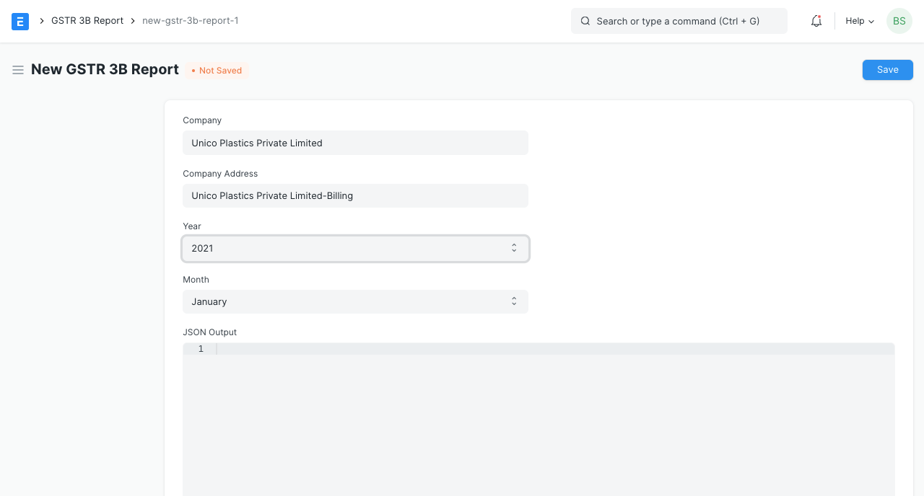

* + - After saving you can see the JSON output in the text field below which can also be downloaded by using the Download JSON button in the top right corner as shown in the image below.

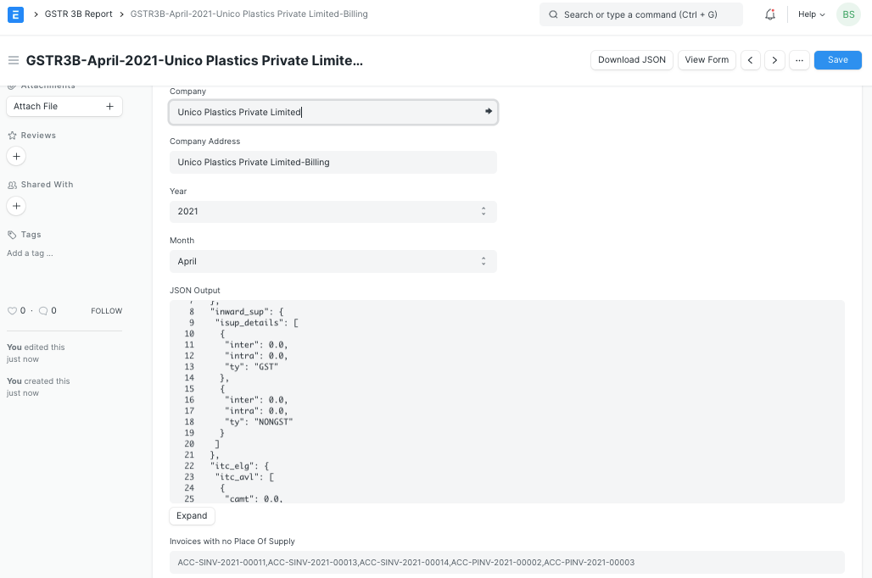

* + - If you want to print the report it can also be printed and viewed in GSTR3B Form by clicking on View Form as shown below

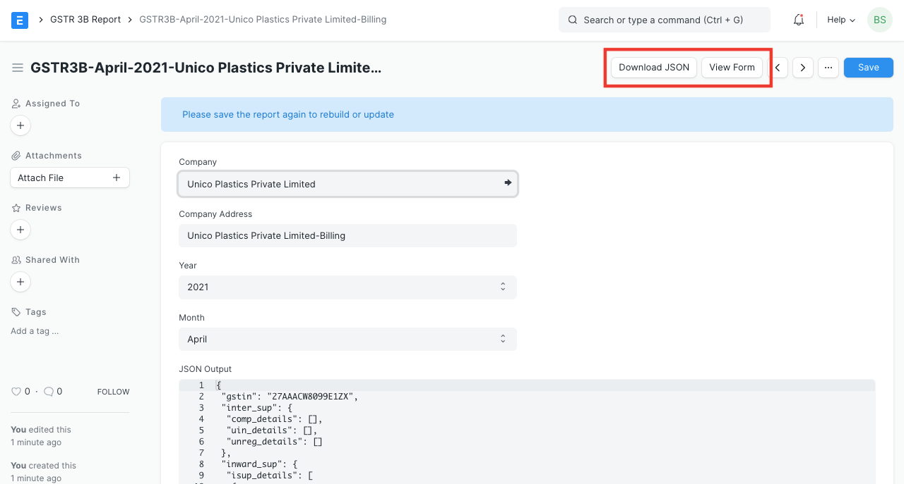

* + - Note: To make sure the report is calculated accurately and correctly please make sure of the following things.

1. Since GST is a destination-based tax, please make sure all C-formIndian Customers and Suppliers have a GST state (even the Unregistered ones).
2. Nil rated, exempt or Non-GST items have Is nil rated or Is Non-GST checkbox is checked in the item master.
   * + 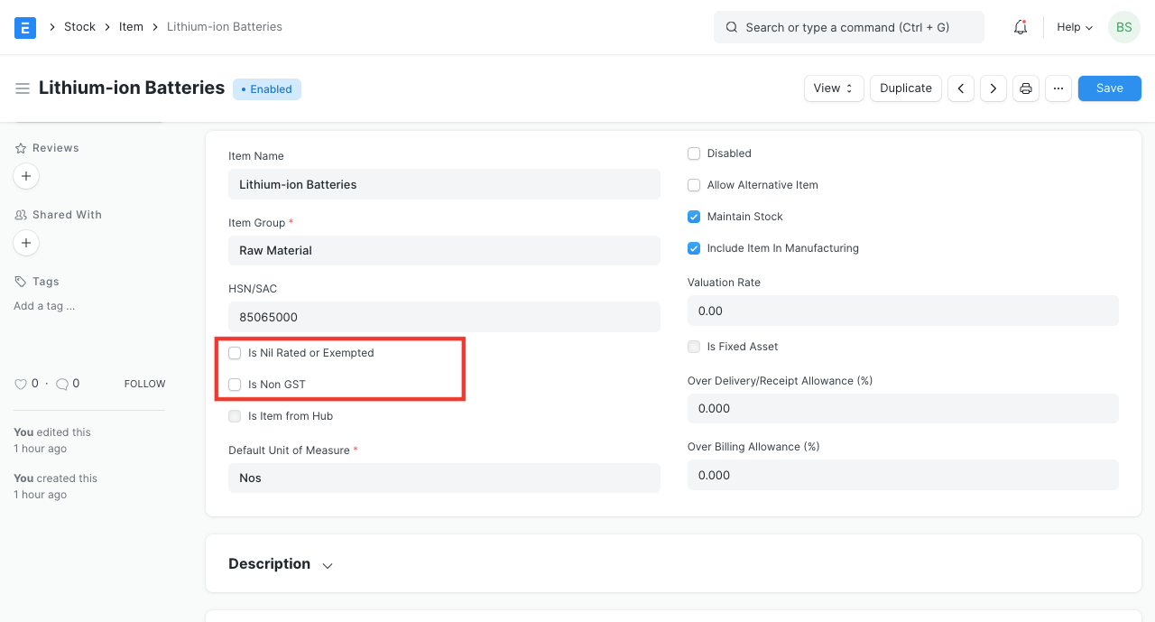
   * **C-Form:-**
     + Any inter-state business transaction needs a certificate to be pursued, which is termed as C form. It is basically issued by the seller of goods to the buyer of goods for the purpose of effecting a reduction on the rate of tax.
     + C-Form shall have the following fields:

| Label (Fields) | Type (Fields) | Options (Fields) | Mandatory (Fields) |
| --- | --- | --- | --- |
| C-Form No | Data |  | 1 |
| Received Date | Date |  | 1 |
| Customer | Link | Customer | 1 |
| Company | Link | Company | 0 |
| Quarter | Select | I  II  III  IV | 0 |
| Total Amount | Currency | Company:company:default_currency | 1 |
| State | Data |  | 1 |
| Invoices | Table | C-Form Invoice Detail | 0 |
| Total Invoiced Amount | Currency | Company:company:default_currency | 0 |
| Amended From | Link | C-Form | 0 |

# **Lower Deduction Certificate**

* + - According to the tax withholding category, a person responsible for making payments is required to deduct tax at source at prescribed rates. Instead of receiving tax on your income from you at a later date, the government wants the payers to deduct tax beforehand and deposit it with the government. However this scheme of deducting tax at source may cause issues to a few taxpayers who may not have taxable income for that fiscal year.
    - Therefore, for such taxpayers, the government provides an option to obtain a certificate confirming to either a lower rate or NIL rate of TDS compared to the rate specified in the tax withholding category

# Lower Deduction Certificate shall have the following fields:

| Label (Fields) | Type (Fields) | Options (Fields) | Mandatory (Fields) |
| --- | --- | --- | --- |
| Tax Withholding Category | Link | Tax Withholding Category | 1 |
| Fiscal Year | Link | Fiscal Year | 1 |
| Certificate No | Data |  | 1 |
| Supplier | Link | Supplier | 1 |
| PAN No | Data |  | 1 |
| Valid From | Date |  | 1 |
| Valid Upto | Date |  | 1 |
| Rate Of TDS As Per Certificate | Percent |  | 1 |
| Certificate Limit | Currency |  | 1 |

* **Share Management:-**
  + **Shareholder:-**
    - A Shareholder is someone who owns shares of a Company.
    - A Shareholder is any person, company or other institution that owns at least one share of a company’s stock. Because shareholders are a company's owners, they reap the benefits of the company's successes in the form of increased stock valuation. If the company does poorly, shareholders can lose money if the price of company stock declines.
    - Any profit or loss made by a Company belongs to the Shareholders and hence the Shareholders are a liability to the Company.
    - Shareholder shall have the following fields:

| Field Name | Type | Link | Mandatory |
| --- | --- | --- | --- |
| Title | Data |  | 1 |
| Folio no. | Data |  | 0 |
| Company | Link | Company | 1 |
| Is Company | Check |  | 0 |
| Address HTML | HTML |  | 0 |
| Contact HTML | HTML |  | 0 |
| Share Balance | Table | Share Balance | 0 |
| Contact List | Code |  | 0 |

* + **Share Transfer:-**
    - A Share Transfer is the Issue, Transfer, or Purchase of Company shares from one party to another.
    - There may be times when you want to change the share structure of your Company; either by adding new Shareholders or by changing the existing proportion of shares between Shareholders. A Share Transfer is the process of transferring existing shares from one person to another; either by sale or gift.
    - When creating a new Shareholder, they need to be issued shares first. Only then a Folio Number is visible and further transfer can be done using that Shareholder.
    - Share Transfer shall have the following fields:-

| Label (Fields) | Type (Fields) | Options (Fields) | Mandatory (Fields) |
| --- | --- | --- | --- |
| Transfer Type | Select | Issue  Purchase  Transfer | 1 |
| Date | Date |  | 1 |
| From Shareholder | Link | Shareholder | 0 |
| From Folio No | Data |  | 0 |
| To Shareholder | Link | Shareholder | 0 |
| To Folio No | Data |  | 0 |
| Equity/Liability Account | Link | Account | 1 |
| Asset Account | Link | Account | 0 |
| Share Type | Link | Share Type | 1 |
| From No | Int |  | 1 |
| Rate | Currency |  | 1 |
| No of Shares | Int |  | 1 |
| To No | Int |  | 1 |
| Amount | Currency |  | 0 |
| Company | Link | Company | 1 |
| Remarks | Long Text |  | 0 |
| Amended From | Link | Share Transfer | 0 |

* **Cost Center and Budgeting:-**
  + **Budget :-**
    - Budgeting is a financial plan that helps control Company expenses.
    - You can set and manage budgets against a Cost Center or a Project. This is useful in controlling your expenses.
    - Budgets are also great for planning purposes. When you are making plans for the next Financial Year, you would typically target a revenue based on which you would set your expenses. Setting a budget will ensure that your expenses do not get out of hand at any point.
    - Budget shall have the following fields:

| Label (Fields) | Type (Fields) | Options (Fields) | Mandatory (Fields) |
| --- | --- | --- | --- |
| Budget Against | Select | Cost Center  Project | 1 |
| Company | Link | Company | 1 |
| Cost Center | Link | Cost Center | 0 |
| Project | Link | Project | 0 |
| Fiscal Year | Link | Fiscal Year | 1 |
| Monthly Distribution | Link | Monthly Distribution | 0 |
| Amended From | Link | Budget | 0 |
| Applicable on Material Request | Check |  | 0 |
| Action if Annual Budget Exceeded on MR | Select | Stop Warn Ignore | 0 |
| Action if Accumulated Monthly Budget Exceeded on MR | Select | Stop Warn Ignore | 0 |
| Applicable on Purchase Order | Check |  | 0 |
| Action if Annual Budget Exceeded on PO | Select | Stop Warn Ignore | 0 |
| Action if Accumulated Monthly Budget Exceeded on PO | Select | Stop Warn Ignore | 0 |
| Applicable on booking actual expenses | Check |  | 0 |
| Action if Annual Budget Exceeded on Actual | Select | Stop Warn Ignore | 0 |
| Action if Accumulated Monthly Budget Exceeded on Actual | Select | Stop Warn Ignore | 0 |
| Budget Accounts | Table | Budget Account | 1 |

### **Accounting Dimension :-**

* + - Dimensional accounting means tagging each transaction with appropriate dimensions like Branch, Business Unit, etc. This allows you to maintain each segment separately, thereby limiting the overall maintenance on GL accounts and your Chart of Accounts remains pure.
    - Cost Center and Project are treated as dimensions by default. On setting a field in Accounting Dimension, that field will be added in transactions reports where applicable.
    - Accounting Dimension shall have following fields:

| Field Name | Type | Link | Mandatory |
| --- | --- | --- | --- |
| Reference Document Type | Link | DocType | 1 |
| Dimension Name | Data |  | 0 |
| Fieldname | Data |  | 0 |
| Dimension Defaults | Table | Accounting Dimension Detail | 0 |
| Disable | Check |  | 0 |

### **Monthly Distribution:-**

* + - You can also define a Monthly Distribution record to distribute the budget between months. If you don't set the monthly distribution, Here we will calculate the budget yearly or in equal proportion for every month.
    - Monthly Distribution shall have the following fields:

| Label (Fields) | Type (Fields) | Options (Fields) | Mandatory (Fields) |
| --- | --- | --- | --- |
| Distribution Name | Data |  | 1 |
| Fiscal Year | Link | Fiscal Year | 0 |
| Monthly Distribution Percentages | Table | Monthly Distribution Percentage | 0 |

* **Opening and Closing:-**
  + **Opening Invoice Creation Tool:-**
    - The Opening Invoice Creation Tool allows importing data of outstanding Purchase or Sales Invoices. This specific tool is used in place of the Data Import Tool for cases where the Item data is irrelevant and outstanding balances against Customers/Suppliers are to be imported
    - This shall have the following fields:

| Company | Link | Company | 1 |
| --- | --- | --- | --- |
| Create Missing Party | Check |  | 0 |
| Invoice Type | Select | Sales  Purchase | 1 |
| Cost Center | Link | Cost Center | 0 |
| Invoice | Table | Opening Invoice Creation Tool Item | 1 |

### **Period Closing Voucher :-**

* + - A Period Closing Voucher indicates that the profit/loss for an accounting period has been balanced and the books can start fresh.
    - At the end of every year or (quarterly or maybe even monthly), after completing auditing, you can close your books of accounts. This means that you make all your special entries like:
* Depreciation
* Change in value of Assets
* Defer taxes and liabilities
* Update bad debts
  + - By doing this, your balance in your Income and Expense Accounts becomes zero. You start a new Fiscal Year (or period) with a balanced Balance Sheet and fresh Profit and Loss account. After making all the special entries via Journal Entry for the current fiscal year, you should set all your Income and Expense accounts to zero via a Period Closing Voucher.
    - Period Closing Voucher shall have the following fields:-

| Label (Fields) | Type (Fields) | Mandatory (Fields) | Options (Fields) |
| --- | --- | --- | --- |
| Transaction Date | Date | 0 |  |
| Posting Date | Date | 1 |  |
| Closing Fiscal Year | Link | 1 | Fiscal Year |
| Amended From | Link | 0 | Period Closing Voucher |
| Company | Link | 1 | Company |
| Book Cost Center Wise Profit/Loss | Check | 0 |  |
| Closing Account Head | Link | 1 | Account |
| Remarks | Small Text | 1 |  |

### **Taxes :-**

### **Sales Taxes and Charges Template :-**

* + - Sales Taxes and Charges may be applied to any item you sell.
    - The templates created from this form can be used in Sales Orders and Sales Invoices.
    - For Tax Accounts that you want to use in the tax templates, you must set the Account Type field as 'Tax' for that particular account. Other types of charges that may apply to your invoices (like shipping, insurance etc.) can also be configured as taxes.
    - This shall have the following fields:-

| Label (Fields) | Type (Fields) | Mandatory (Fields) | Options (Fields) |
| --- | --- | --- | --- |
| Title | Data | 1 |  |
| Default | Check | 0 |  |
| Disabled | Check | 0 |  |
| Company | Link | 1 | Company |
| Tax Category | Link | 0 | Tax Category |
| Sales Taxes and Charges | Table | 0 | Sales Taxes and Charges |

### **Purchase Taxes and Charges Template**

* + - Purchase Taxes and Charges may be applied to any item you buy.
    - The Purchase Taxes and Charges Template is similar to the Sales Taxes and Charges Template. The templates created from this form can be used in Purchase Orders and Purchase Invoices for internal records.
    - For Tax Accounts that you want to use in the tax templates, you must set the Account Type field as 'Tax' for that particular account.
    - This shall have the following fields:

| Field Name | Type | Mandatory | Link |
| --- | --- | --- | --- |
| Title | Data | 1 |  |
| Default | Check | 0 |  |
| Disabled | Check | 0 |  |
| Company | Link | 1 | Company |
| Tax Category | Link | 0 | Tax Category |
| Purchase Taxes and Charges | Table | 0 | Purchase Taxes and Charges |

### **Item Tax Template :-**

* + - If some of your Items have tax rates different from the standard tax rate assigned in the Taxes and Charges table, then you can create an Item Tax Template and assign it to an Item or Item Group. The rate assigned in the Item Tax Template will get preference over the standard tax rate assigned in the Taxes and Charges table.
    - For example, if tax GST 18% is added in the Taxes and Charges table in Sales Order, then it will be applied on all the items in that Sales Order.
    - Item Tax Template shall have the following fields:-

| Label (Fields) | Type (Fields) | Mandatory (Fields) | Options (Fields) |
| --- | --- | --- | --- |
| Title | Data | 1 |  |
| Company | Link | 1 | Company |
| Disabled | Check | 0 |  |
| Tax Rates | Table | 1 | Item Tax Template Detail |

### **Tax Category:**

* + - A Tax Category allows applying one or more Tax Rules to transactions based on various criteria.
    - Tax Category shall have the following fields:-

| Label (Fields) | Type (Fields) | Mandatory (Fields) | Options (Fields) |
| --- | --- | --- | --- |
| Title | Data | 1 |  |
| Disabled | Check | 0 |  |

### **Tax Rule:-**

* + - A Tax Rule automatically applies taxes to transactions based on preset rules.
    - You can define whichTax Template must be applied on a Sales / Purchase transaction using the Tax Rule. This is decided by various factors like Customer, Customer Group, Supplier, Supplier Group, Item, Item Group or a combination of these.
    - Tax Rule shall have the following fields:-

| Label (Fields) | Type (Fields) | Mandatory (Fields) | Options (Fields) |
| --- | --- | --- | --- |
| Tax Type | Select | 0 | Sales  Purchase |
| Use for Shopping Cart | Check | 0 |  |
| Sales Tax Template | Link | 0 | Sales Taxes and Charges Template |
| Purchase Tax Template | Link | 0 | Purchase Taxes and Charges Template |
| Customer | Link | 0 | Customer |
| Supplier | Link | 0 | Supplier |
| Item | Link | 0 | Item |
| Billing City | Data | 0 |  |
| Billing County | Data | 0 |  |
| Billing State | Data | 0 |  |
| Billing Zipcode | Data | 0 |  |
| Billing Country | Link | 0 | Country |
| Tax Category | Link | 0 | Tax Category |
| Customer Group | Link | 0 | Customer Group |
| Supplier Group | Link | 0 | Supplier Group |
| Item Group | Link | 0 | Item Group |
| Shipping City | Data | 0 |  |
| Shipping County | Data | 0 |  |
| Shipping State | Data | 0 |  |
| Shipping Zipcode | Data | 0 |  |
| Shipping Country | Link | 0 | Country |
| From Date | Date | 0 |  |
| To Date | Date | 0 |  |
| Priority | Int | 0 |  |
| Company | Link | 0 | Company |

### **Tax Withholding Category:-**

* + - Tax Withholding Category is Tax Deducted at Source.
    - According to this, a person responsible for making payments is required to deduct tax at source at prescribed rates. Instead of receiving tax on your income from you at a later date, the government wants the payers to deduct tax beforehand and deposit it with the government.

| Label (Fields) | Type (Fields) | Mandatory (Fields) | Options (Fields) |
| --- | --- | --- | --- |
| Category Name | Data | 0 |  |
| Round Off Tax Amount | Check | 0 |  |
| Consider Entire Party Ledger Amount | Check | 0 |  |
| Only Deduct Tax On Excess Amount | Check | 0 |  |
| Rates | Table | 1 | Tax Withholding Rate |
| Accounts | Table | 1 | Tax Withholding Account |

### **Setting:-**

* + **Payment Gateway Account :-**
    - Payment Gateway Account is **configuration hub** from which you can set account head from existing COA, default Payment Request email body template. After enabling service and configuring Payment Gateway Account your system is able to accept online payments.
    - Payment Gateway Account shall have the following fields

| Label (Fields) | Type (Fields) | Mandatory (Fields) | Options (Fields) |
| --- | --- | --- | --- |
| Payment Gateway | Link | 1 | Payment Gateway |
| Payment Channel | Select | 0 | Email  Phone |
| Is Default | Check | 0 |  |
| Payment Account | Link | 1 | Account |
| Currency | Read Only | 0 |  |
| Default Payment Request Message | Small Text | 0 |  |

### **Terms and Conditions:-**

* + - Terms and conditions contain the terms and conditions of a service/product offered by a seller to a buyer.
    - Each Quotation/Sales Order must ideally contain a set of terms of your contract. Terms and conditions are usually included to define terms of service, conditions for using any service or to even limit responsibilities of the seller in case any harm is caused to the buyer due to using the provided goods or services. It is usually a good idea to make template(s) of your Terms and Conditions so that you have a standard set of terms
    - Terms and conditions shall have the following fields:-

| Label (Fields) | Type (Fields) | Mandatory (Fields) | Options (Fields) |
| --- | --- | --- | --- |
| Title | Data | 1 |  |
| Disabled | Check | 0 |  |
| Applicable Modules | Section Break | 0 |  |
| Selling | Check | 0 |  |
| Buying | Check | 0 |  |
| HR | Check | 0 |  |
| Terms and Conditions | Text Editor | 0 |  |

### 

### 

### **Mode of Payment :-**

* + - In the sales and purchase transactions, there are various options to settle the payment. We can do it in cash, via bank transfer, via promotion voucher to list a few. Here, you can create a Mode of Payments as per your requirement. In the Payment Entry, you can select the Mode of Payment applicable.
    - Mode of Payment shall have the following fields :

| Label (Fields) | Type (Fields) | Mandatory (Fields) | Options (Fields) |
| --- | --- | --- | --- |
| Mode of Payment | Data | 1 |  |
| Enabled | Check | 0 |  |
| Type | Select | 0 | Cash  Bank  General  Phone |
| Accounts | Table | 0 | Mode of Payment Account |

### **Other Reports :-**

### **UAE VAT 201 :-**

* + - Correct Emirate is selected in Company Address and Sales Invoice. The Sales Invoice Emirate field is auto filled using the selected Company Address but is editable.
    - Zero Rated or Exempted Items have "Is Zero Rated" or "Is Exempt" checkbox checked in the item master.
    - All VAT accounts are selected in UAE VAT Settings.
    - 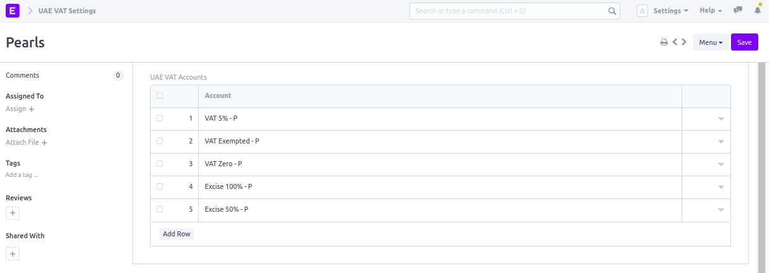
    - 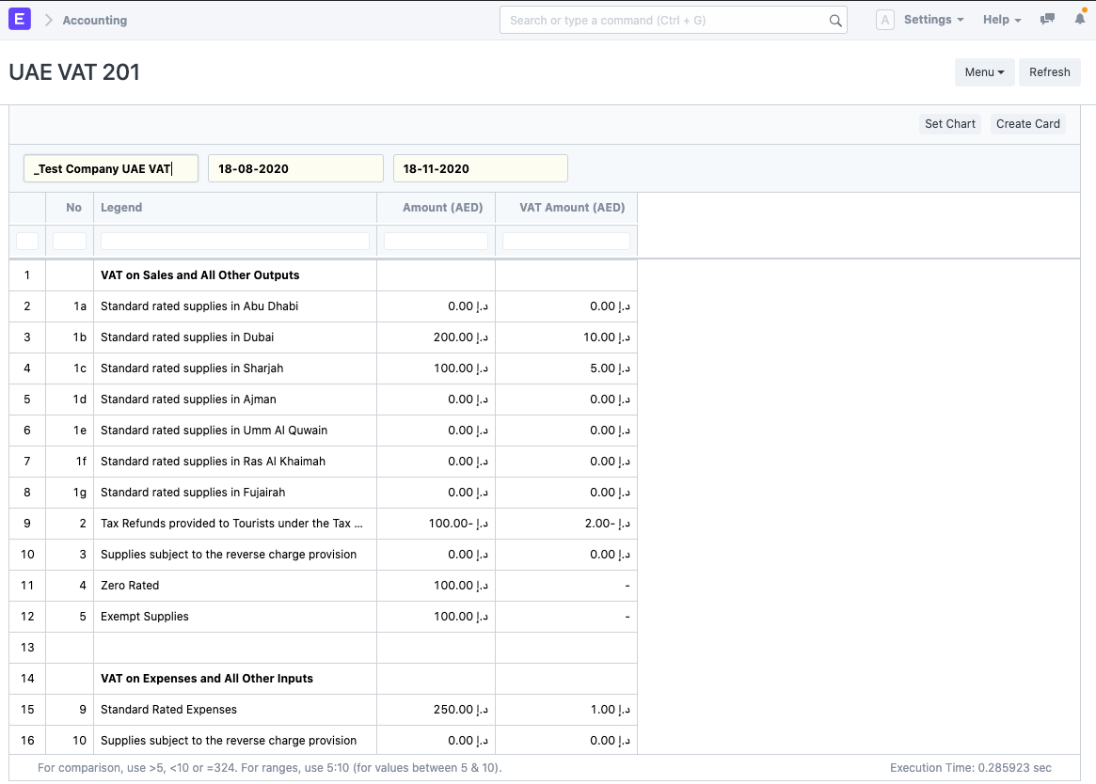

### **DATEV Settings:** DATEV Settings are required for each Company to be able to use the DATEV Export. It contains the following fields:

* + - Company for which these settings should apply.
    - Account Number Length. Length of your GL Account numbers. This is the length of your usual account numbers. The numbers of personal accounts may be longer.
    - Client ID. This is your company's customer number at your tax advisor.
    - Consultant ID. This is your tax advisor's identification assigned by DATEV.
    - Consultant. A link to your tax advisor's Supplier record.
    - Temporary Against Account Number. To DATEV it will look as if all your GL Entries were made against this account. It is needed to resolve differences between the two accounting systems.
    - The German DATEV eG is a registered cooperative of the tax, accountancy and legal professions. The DATEV format is a CSV-based file interface for importing data into DATEV Accounting. The interface documentation is available in the DATEV developer portal:
    - 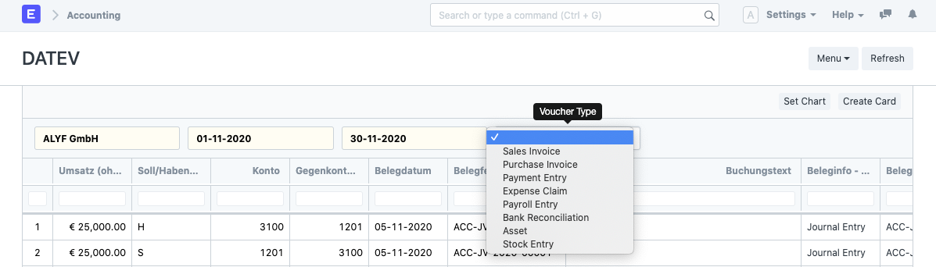
  + **GST Settings :-**
    - 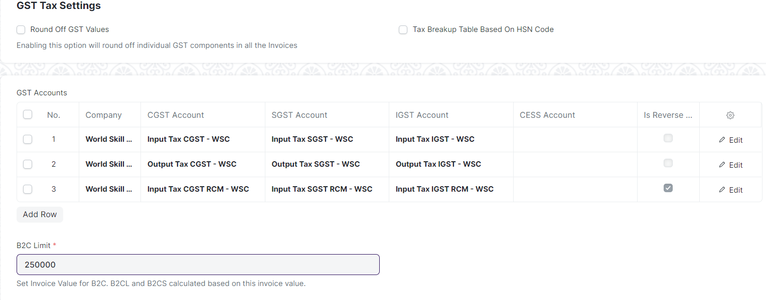
  + **GSTR-1 :-**
    - Form GSTR-1 is a monthly/quarterly Statement of Outward Supplies to be furnished by all normal and casual registered taxpayers making outward supplies of goods and services or both and contains details of outward supplies of goods and services.
    - Update filters as per return period and type of Business ( invoice Type) to get the required data:-
    - 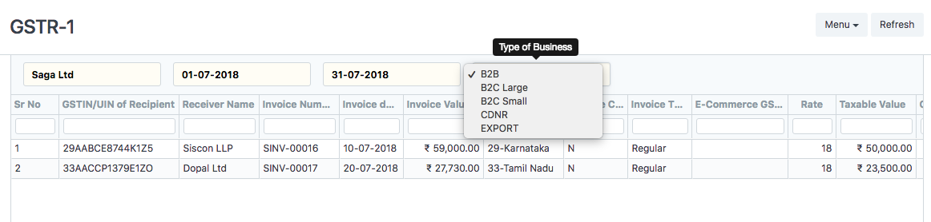
  + **GSTR-2 :-**
    - The GSTR-2 is a monthly tax return showing the purchases you’ve made for that month. When you make purchases from registered vendors, the information from their sales returns (GSTR-1)will be available in the GSTN portal as GSTR2A for you to use in your GSTR-2. Before you file your return, you can check this information, make changes if necessary, and add any details that were not auto-populated.
  + **Bank Reconciliation Statement :-**
    - The Bank Reconciliation Report provides the difference between the bank balance shown in an organization's bank statement, as provided by the bank against the amount shown in the companies Chart of Accounts.
    - 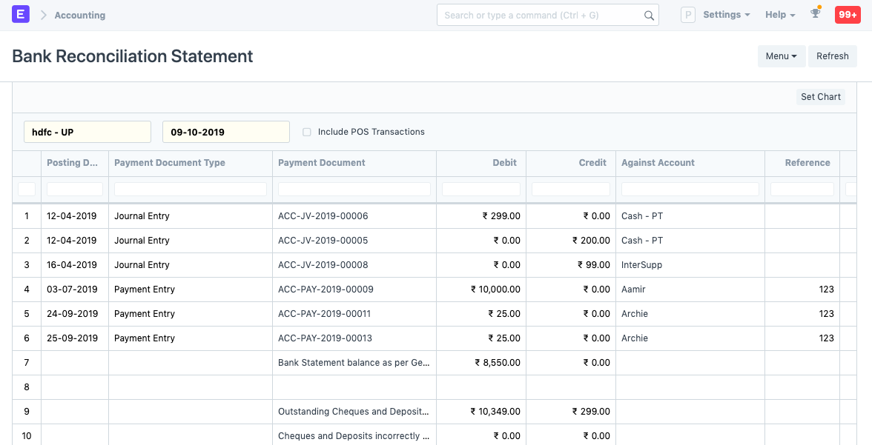This is what a Bank Reconciliation statement looks like:
  + **KSA VAT Settings :-**
    - KSA VAT Setting is **created automatically**. For any new companies create new settings. Note: Multiple Item Tax Template can be set for each item. A good example in the sales cycle would be an item that is treated as a Standard rated Sales and as well as Zero rated domestic Sales.
    - KSA VAT Shall have the following fields

| Label | Type | Mandatory | Link |
| --- | --- | --- | --- |
| Company | Link | 1 | Company |
| KSA VAT Sales Accounts | Table | 1 | KSA VAT Purchase Accounts |
| KSA VAT Purchase Accounts | Table | 1 | KSA VAT Purchase Accounts |